**MS-DOS COMMANDS**

**MS-DOS COMMANDS**

**DOS Commands are divided into 2 types:**

1. **Internal Commands**

These are for performing basic operations on files and directories and they do not need any external file support.

1. **External Commands**

These external commands are for performing advanced tasks and they do need some external file support as they are not stored in COMMAND.COM

***Internal Commands :-***

**General purpose commands :-**

1.**dir (directory) :-**  dir will show All The files & Folders in the location with details.

2 **dir/p (directory/page wise) :-** dir will show All The files & Folders display with details page wise.

3.**dir/w(directory/window) :-** dir/w will show All The files & Folders names only

|  |  |
| --- | --- |
| **/p** | **Page wise** |
| **/w** | **Width wise** |
| **/s** | **List of all files and directories of subdirectories** |
| **/AH** | **Display directories with hidden files** |
| **/AS** | **Display directory with system files** |
| **/AD** | **Display only directories present in current drive** |

4 .**time :-** display the time based on user cpu time

5. **Date *:*-** display the time based on user cpu date

6.**Cls(clear screen):-** it clear the screen

7.**Move :-** move the file from one location to another folder

8.**ren :-** if you want to rename a file from existing file then use this cmd

9.**Create Text File :-** this command is used to create a new text file ie ***copy con filename.txt***

10.**Ver :-** this command will show version of window what kind of version we use

11.**CD(change directory) :-**  this command is used to change the directory **cd filename**

12.**Cd .. :-** this command is used to goes back one directory

13.**Cd ../../../ :-** this command is used to goes back as depends on couple of dotes(..) **cd ../../**

14.**batch file :-** this command is used to goes back as depends on couple of dotes(..)**Copy con file.bat**

vinay

vamshi

kiran

raghu^Z

to excute batchfile just type file name .

15.**tree :-** Generally display the directory structure of a drive or path **C:\>tree**

16. **Rd (Remove directory):-** This command is used to remove any directory from a disk

To remove directory the directory should be empty **d:\rd<Dirname>**

17. **CD\:-** Goto the root

18. **VOL (volume):**

Displays the disk volume label and serial number, If it exist

**C:\>vol**

19.type:- The command is used to display the contents or text of any file to the display device.

**C:\>TYPE<filename>.txt**

***External Commands :-***

These external commands are for performing advanced tasks and they do need some external file support as they are not stored in COMMAND.COM

**A)CD:** Go to one folder back.

**B) CD\:** Go to the root

**C) D**: Change the drive**.**

**D) DIR/P**: Page wise

**E) DIR/W/P:** Window and page wise

**1) ATTRIB**: Displays or changes file attributes.

**2) CD**: Displays the name of or changes the current directory.

**3) CHDIR**: Displays the name of or changes the current directory.

**4) CHKDSK**: check a disk and displays a status report.

**5) CLS**: Clears the screen.

**6) COLOR**: Sets the default console foreground and background colors.

**7) COPY**: Copies one or more files to another location.

**8) DATE**: Displays or sets the date.

**9) DEL**: Deletes one or more files.

**10) DIR**: Displays a list of files and subdirectories in a directory.

**11) DISKCOMP**: Compares the contents of two floppy disks.

**12) DISKCOPY**: Copies the contents of one floppy disk to another .

**14) EXIT**: Quits the CMD>EXE program (command interpreter)

**15) FIND**: Searches for a text string in a file or files.

**16) FORMAT**: Formats a disk for use with windows.

**17) HELP**: Provides help information for windows commands

**18) LABEL**: Creates, changes, or deletes the volume label of a disk.

**19) MD**: Creates a directory

**20) MOVE**: Moves one or more files from one directory to another directory.

**21) PRINT**: Prints a text file.

**22) RD**: Removes a directory.

**23) REN**: Rename a file or files.

**24) TYPE**: Displays the contents of a text file.

**25) VER**: Displays the window version.

**26) XCOPY**: Copies files and directory trees.

**MS-WORD**

**1,Create a leave-letter using MS Word**

**Procedure:**

* Click “START” button on desktop.
* Select “PROGRAMS” and click on “MS-WORD”. Then choose Microsoft Word.
* Now you will see a blank word document on the screen.
* On the tab at the upper left side of your screen, hit the “File” tab. On the vertical toolbar to the left, hit the “New” tab.
* Now you start to write a leave letter as you known in the word document
* You can write the leave letter by using the different font styles and font sizes from tool bar of your word document and set page setup.
* Once you finished with your word document by entering the details of regarding leave letter, go to “File >Save As” and save your file so that you can retrieve it later.

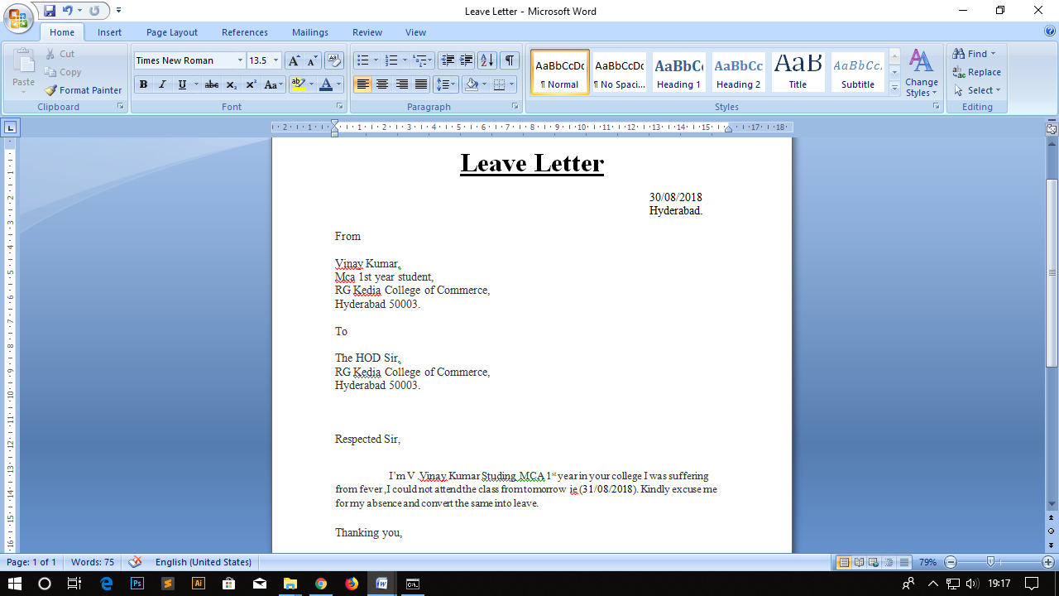

**2, Create Time Table MCA 1st year 1st semester.**

**Procedure:**

* Click “START” button on desktop.
* Select “PROGRAMS” and click on “MS-OFFICE”. Then choose MS-Word.
* Now you will see a blank word document on the screen.
* Now “SAVE” the document by giving appropriating name. While you going to save the file you find a “SAVE AS” option in explorer bar i.e., the where you want to save the particular file.
* Now select “INSERT” option in the main menu bar. In that choose “TABLE” and choose how many rows and columns do you want.
* After creating a time table if needed merge the fields by using” merge” option.

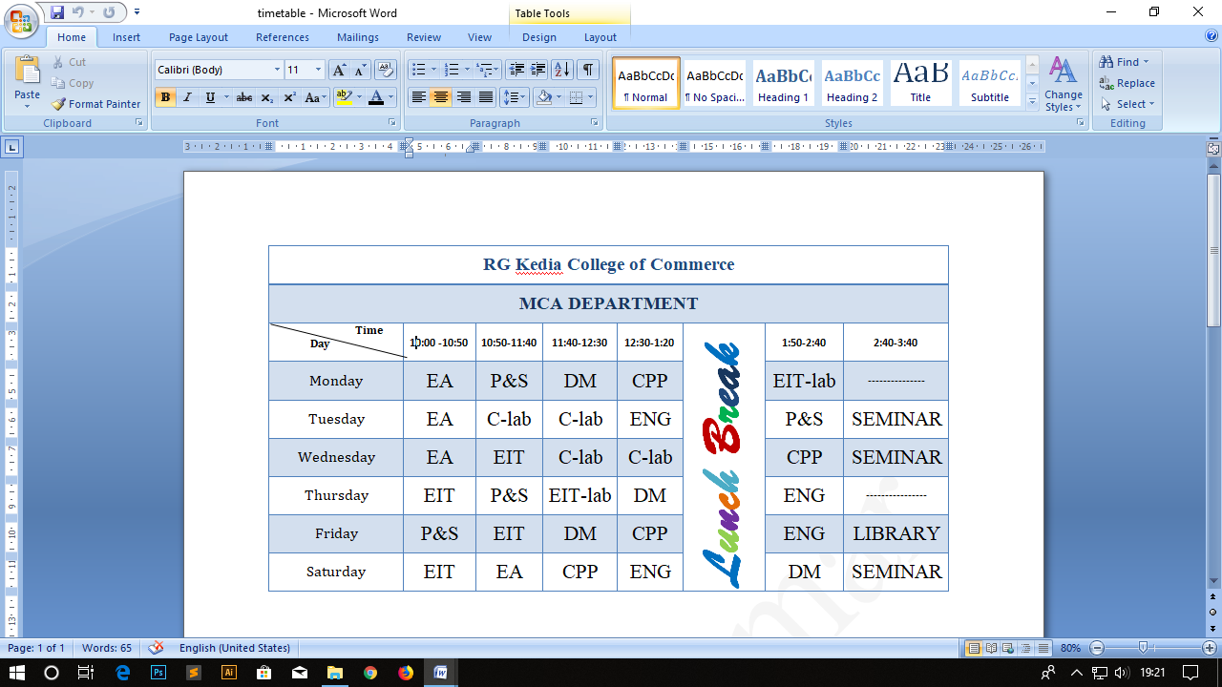

**3, MS-word Search, Search and Replace options with an example**

**Procedure:**

* Click “START” button on desktop.
* Select “PROGRAMS” and click on “MS-OFFICE”. Then choose MS-Word.
* Now you will see a blank word document on the screen.
* Now “SAVE” the document by giving appropriating name. While you going to save the file you find a “SAVE AS” option in explorer bar i.e., the where you want to save the particular file.
* Click on edit option present in “Menu bar”.
* Then click on “**Find**” option. Then it shows a window contains,

Find, Replace, Go to Options.

* Select “Find” option and enter the word which you want to search.
* If we want to replace, select **“replace”** option present in that window.
* Click “enter” then it replace the word.

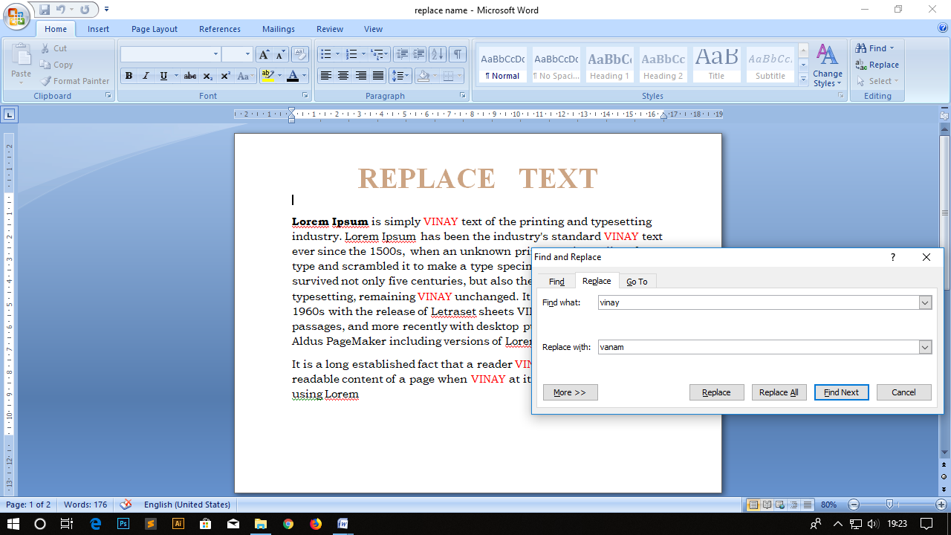

**4, Create a Macro**

**Procedure :**

* Click “START” button on desktop.
* Select “PROGRAMS” and click on “MS-OFFICE”. Then choose MS-Word.
* Now you will see a blank word document on the screen.
* Now “SAVE” the document by giving appropriating name. While you going to save the file you find a “SAVE AS” option in explorer bar i.e., the where you want to save the particular file.
* Select “Tool” option from menu bar and then select macro option.
* From that select “Record new macro”. Then give an appropriate name on showing window. After the recording of macro select option “Stop recording macro”. To use the macro go to “Macros” and view macro in that run the macro.

Then use this macro where you want to use.

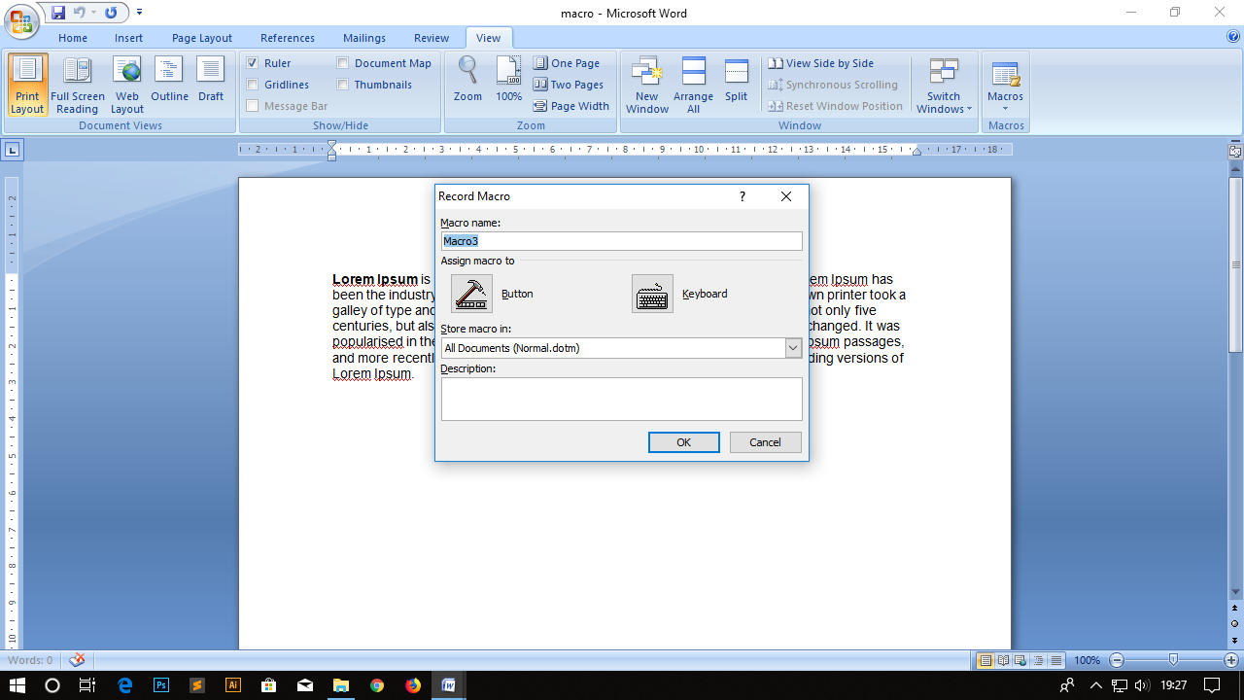

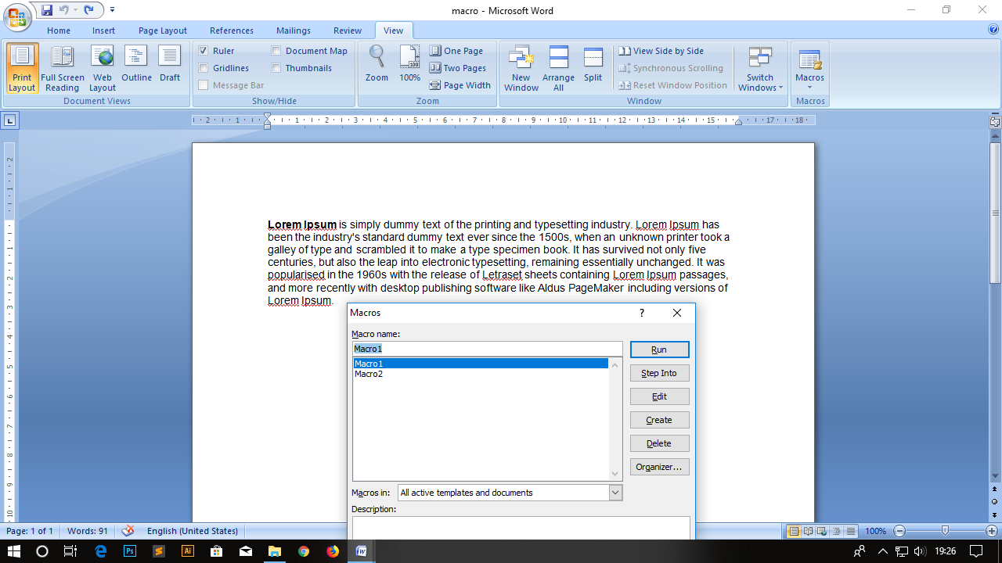

**5,** **Create a page header and footer and insert page numbers**

**Procedure :**

* Click “START” button on desktop.
* Select “PROGRAMS” and click on “MS-OFFICE”. Then choose MS-Word.
* Now you will see a blank word document on the screen.
* Now “SAVE” the document by giving appropriating name. While you going to save the file you find a “SAVE AS” option in explorer bar i.e., the where you want to save the particular file.
* Now go to “INSERT” in that click on” HEADER” and also “FOOTER”.
* Click on page number to give page numbers at the “top of page or bottom of the page”.
* Once you finished with your word document by inserting the details , go to “File >Save As” and save your file so that you can retrieve it later

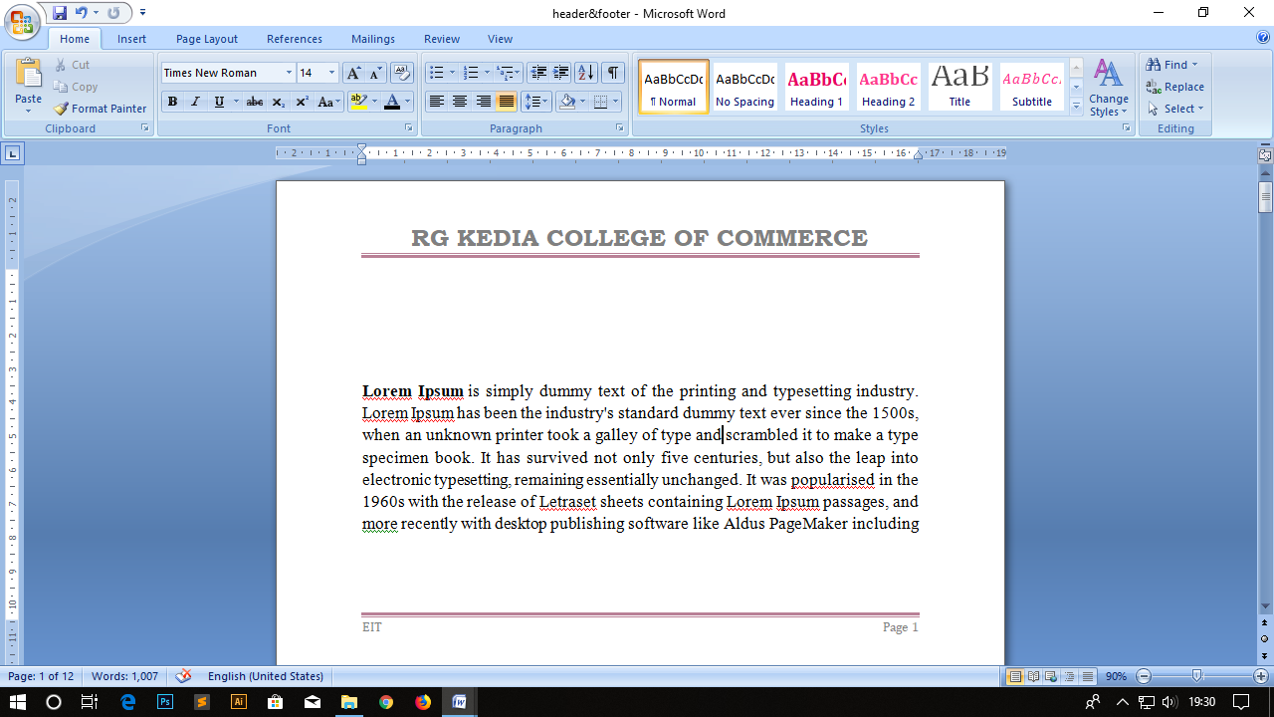

**6, using Mail merge to send seminar invitation to diffrent colleges**

**Procedure :**

* Click “START” button on desktop.
* Select “PROGRAMS” and click on “MS-OFFICE”. Then choose MS-Word.
* Now you will see a blank word document on the screen.
* Now “SAVE” the document by giving appropriating name. While you going to save the file you find a “SAVE AS” option in explorer bar i.e., the where you want to save the particular file.
* Now select mailings option menu bar.
* Then it show “Start mail merge icon under that.
* In that select “step by step mail wizard “.Now you saw the mail merge explorer box on the right side of the word document.
* Then type a invitation.
* Next select recipients list in that type new list .
* Next it will show the details and click on customize columns to enter new fields.
* Next enter the new fields and enter data in the fields.
* Click ok.
* A tool bar will be displayed .In that click on insert merge fields and insert the fields
* Click on finish and merge ok.
* Then it will insert the details and save the document.
* Directly you open a save address list. Now save the details on you location where you want.
* Once you finished with your word document by inserting the details, go to “File >Save As” and save your file so that you can retrieve it later.

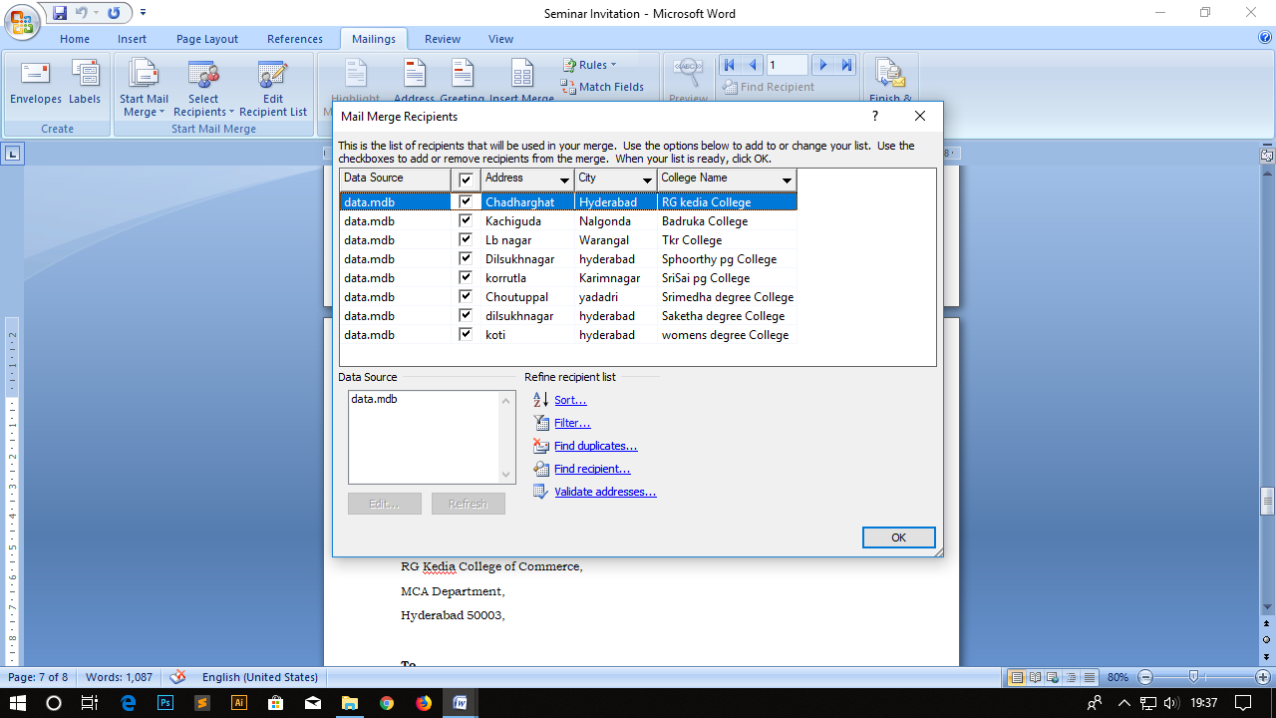

**Seminar Invitation**

Date : 10/09/2018 ,

Hydeabad.

**From**

RG Kedia College of Commerce,

MCA Department,

Hyderabad 50003,

**To**

15 September 2018,

Seminar Invitation,

College Name : RG kedia College,

Address : Chadharghat,

City :Hyderabad ,

Hyderabad.

**Dear Sir,**

I Mr.MCA Department on behalf of RG Kedia college management is writing this letter to invite you all to attend the career counseling seminar that would be held on (15 September 2018) at RG Kedia college at (10:00AM). We would be glad if you participated in this seminar as it will surely help the students of your college to shape their career and resolve all doubts regarding which career field to choose.

This seminar will surely be helpful for all students, thus do participate and gain maximum benefit out of it.

Yours Truly,

RG Kedia College of Commerce

Date : 10/09/2018 ,

Hydeabad.

**From**

RG Kedia College of Commerce,

MCA Department,

Hyderabad 50003,

**To**

15 September 2018,

Seminar Invitation,

College Name : Badruka College,

Address : Kachiguda,

City :Nalgonda ,

Hyderabad.

**Dear Sir,**

I Mr.MCA Department on behalf of RG Kedia college management is writing this letter to invite you all to attend the career counseling seminar that would be held on (15 September 2018) at RG Kedia college at (10:00AM). We would be glad if you participated in this seminar as it will surely help the students of your college to shape their career and resolve all doubts regarding which career field to choose.

This seminar will surely be helpful for all students, thus do participate and gain maximum benefit out of it.

Yours Truly,

RG Kedia College of Commerce

Date : 10/09/2018 ,

Hydeabad.

**From**

RG Kedia College of Commerce,

MCA Department,

Hyderabad 50003,

**To**

15 September 2018,

Seminar Invitation,

College Name : Tkr College,

Address : Lb nagar,

City :Warangal ,

Hyderabad.

**Dear Sir,**

I Mr.MCA Department on behalf of RG Kedia college management is writing this letter to invite you all to attend the career counseling seminar that would be held on (15 September 2018) at RG Kedia college at (10:00AM). We would be glad if you participated in this seminar as it will surely help the students of your college to shape their career and resolve all doubts regarding which career field to choose.

This seminar will surely be helpful for all students, thus do participate and gain maximum benefit out of it.

Yours Truly,

RG Kedia College of Commerce

Date : 10/09/2018 ,

Hydeabad.

**From**

RG Kedia College of Commerce,

MCA Department,

Hyderabad 50003,

**To**

15 September 2018,

Seminar Invitation,

College Name : Sphoorthy pg College,

Address : Dilsukhnagar,

City :hyderabad ,

Hyderabad.

**Dear Sir,**

I Mr.MCA Department on behalf of RG Kedia college management is writing this letter to invite you all to attend the career counseling seminar that would be held on (15 September 2018) at RG Kedia college at (10:00AM). We would be glad if you participated in this seminar as it will surely help the students of your college to shape their career and resolve all doubts regarding which career field to choose.

This seminar will surely be helpful for all students, thus do participate and gain maximum benefit out of it.

Yours Truly,

RG Kedia College of Commerce

Date : 10/09/2018 ,

Hydeabad.

**From**

RG Kedia College of Commerce,

MCA Department,

Hyderabad 50003,

**To**

15 September 2018,

Seminar Invitation,

College Name : SriSai pg College,

Address : korrutla,

City :Karimnagar ,

Hyderabad.

**Dear Sir,**

I Mr.MCA Department on behalf of RG Kedia college management is writing this letter to invite you all to attend the career counseling seminar that would be held on (15 September 2018) at RG Kedia college at (10:00AM). We would be glad if you participated in this seminar as it will surely help the students of your college to shape their career and resolve all doubts regarding which career field to choose.

This seminar will surely be helpful for all students, thus do participate and gain maximum benefit out of it.

Yours Truly,

RG Kedia College of Commerce

Date : 10/09/2018 ,

Hydeabad.

**From**

RG Kedia College of Commerce,

MCA Department,

Hyderabad 50003,

**To**

15 September 2018,

Seminar Invitation,

College Name : Srimedha degree College,

Address : Choutuppal,

City :yadadri ,

Hyderabad.

**Dear Sir,**

I Mr.MCA Department on behalf of RG Kedia college management is writing this letter to invite you all to attend the career counseling seminar that would be held on (15 September 2018) at RG Kedia college at (10:00AM). We would be glad if you participated in this seminar as it will surely help the students of your college to shape their career and resolve all doubts regarding which career field to choose.

This seminar will surely be helpful for all students, thus do participate and gain maximum benefit out of it.

Yours Truly,

RG Kedia College of Commerce

**7, Crete a Visiting Card by using MS-Word.**

**Procedure:**

* Click “START” button on desktop.
* Select “PROGRAMS” and click on “MS-WORD”. Then choose Microsoft Word.
* Now you will see a blank word document on the screen.
* On the tab at the upper left side of your screen, hit the “File” tab. On the vertical toolbar to the left, hit the “New” tab.
* To Create a Visiting in word document first we have set up the page setup in the word document.
* For that select “PAGE LAYOUT” in the main menu bar. Then select “Page Setup option” in that.
* To create Visiting Card give paper size as Height=2cms and Width=3.5cms
* In that enter the details of visiting card as you want.
* Once you finished with your word document by inserting the details of visiting card, go to “File >Save As” and save your file so that you can retrieve it later.

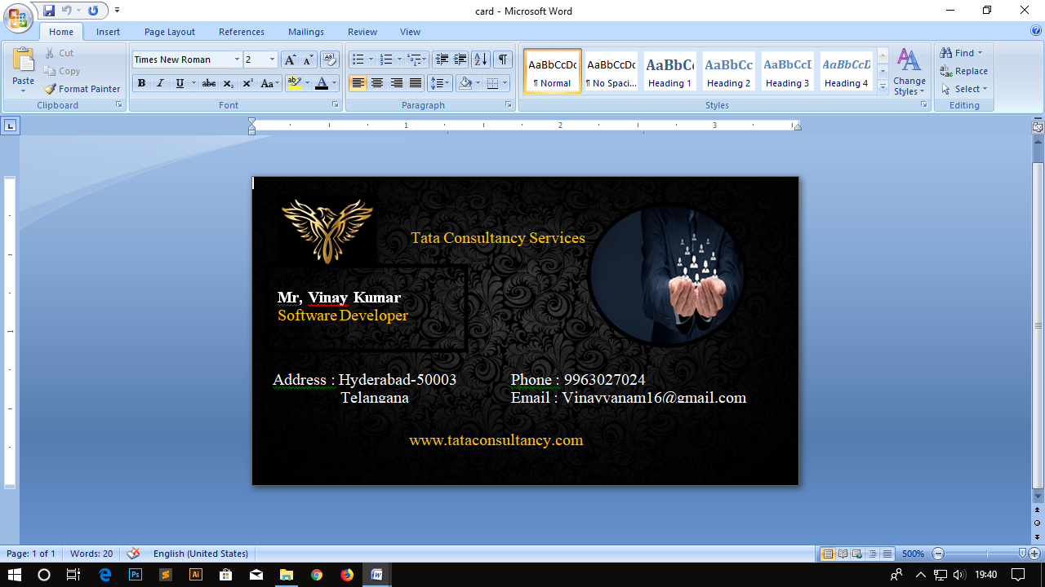

**8, Create hyperlink using MS-WORD**

**Procedure:**

* Click “START” button on desktop.
* Select “PROGRAMS” and click on “MS-OFFICE”. Then choose MS-Word.
* Now you will see a blank word document on the screen.
* Now “SAVE” the document by giving appropriating name. While you going to save the file you find a “SAVE AS” option in explorer bar i.e., the where you want to save the particular file.
* Select the text which you want to give hyperlink.
* Select INSERT option from MENU and then select “Hyperlink”
* Select source file from disk.
* It will gives the hyper link to that particular text

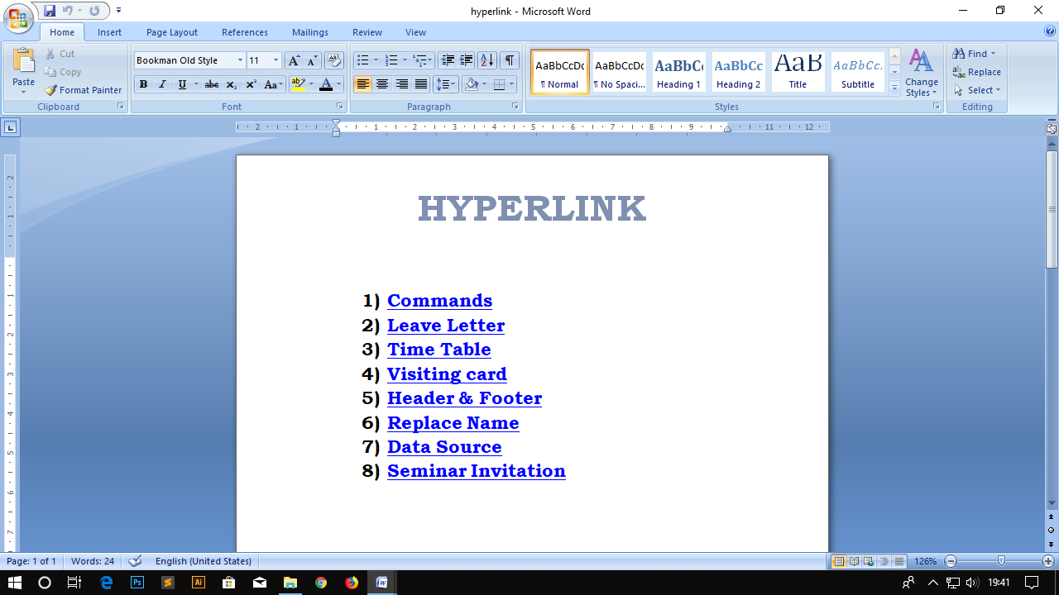

**MS-Excel**

**1, Create time table in excel**

**Procedure**

* Click “START” button on desktop.
* Select “PROGRAMS” and click on “MS-OFFICE”. Then choose MS-Excel.
* Now you will see a blank excel sheet on the screen.
* On the tab at the upper left side of your screen, hit the “File” tab. On the vertical toolbar to the left, hit the “New” tab.
* Merge cell where you want to merge one or more cells using according to the usage.
* Enter the data into cells.
* Save the work.

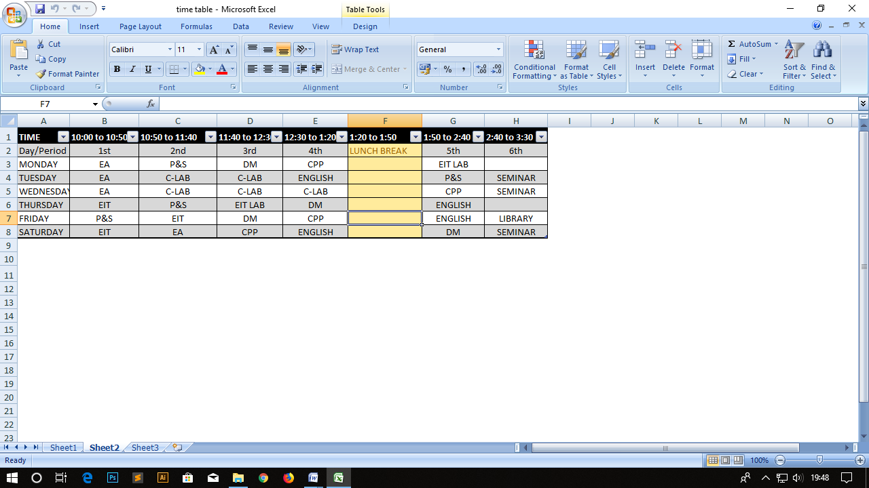

**2,** **Create a table regarding student information calculate total and average**

**Procedure**

* Click “START” button on desktop.
* Select “PROGRAMS” and click on “MS-OFFICE”. Then choose MS-Excel.
* Now you will see a blank excel sheet on the screen.
* On the tab at the upper left side of your screen, hit the “File” tab. On the vertical toolbar to the left, hit the “New” tab.
* Now enter the fields like “ Student number, ”Student name”,“ Discrete Mathematics” “Probability and Statistics”, “C- Programming“ ,“EIT” “Economic Analysis”, “Total Marks” and “Average”.
* Then enter the values to the fields of “Student number” , Name, Subjects.

Then calculate values for “Total Marks” , “Average”.

Formula for these fields is Total Marks: H2=(C2+D2+E2+F2).

Average marks: H2=G2/4.

* Then drag the fields down to calculate the values to all rows.
* It will gives the values of all rows.

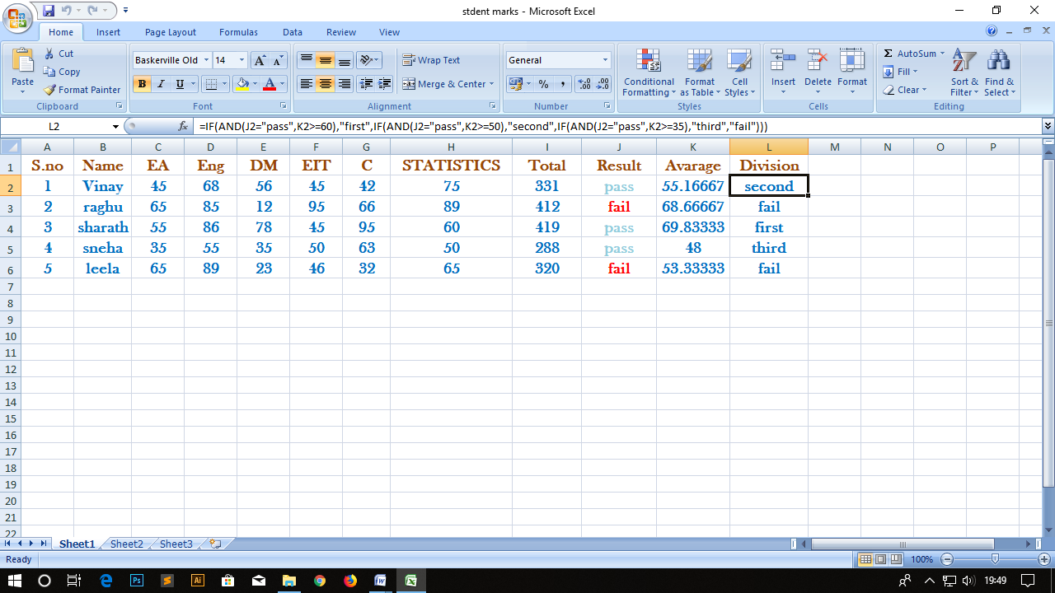

**3,** **Create a student chart with all subjects’ marks total and average**

**Procedure:**

* Click “START” button on desktop.
* Select “PROGRAMS” and click on “MS-OFFICE”. Then choose MS-Excel.
* Now you will see a blank excel sheet on the screen.
* On the tab at the upper left side of your screen, hit the “File” tab. On the vertical toolbar to the left, hit the “New” tab.
* Now enter the fields like “ Student number”, ”Student name”,“ Discrete Mathematics” “Probability and Statistics”, “C-Programming “ ,“EIT” “Economic Analysis”, “Total Marks” and “Average”.
* Then enter the values to the fields of “Student number”. , Name, Subjects.

Then calculate values for “Total Marks” ,“Average”.

Formula for these fields is Total Marks: H2=(C2+D2+E2+F2) Average marks: H2=G2/4.

* Then drag the fields down to calculate the values to all rows.
* It will give the values of all rows.
* Select the data and go to “INSERT” in that click on ”CHARTS”
* A chart tool bar will be displayed .In that select type and design of chart

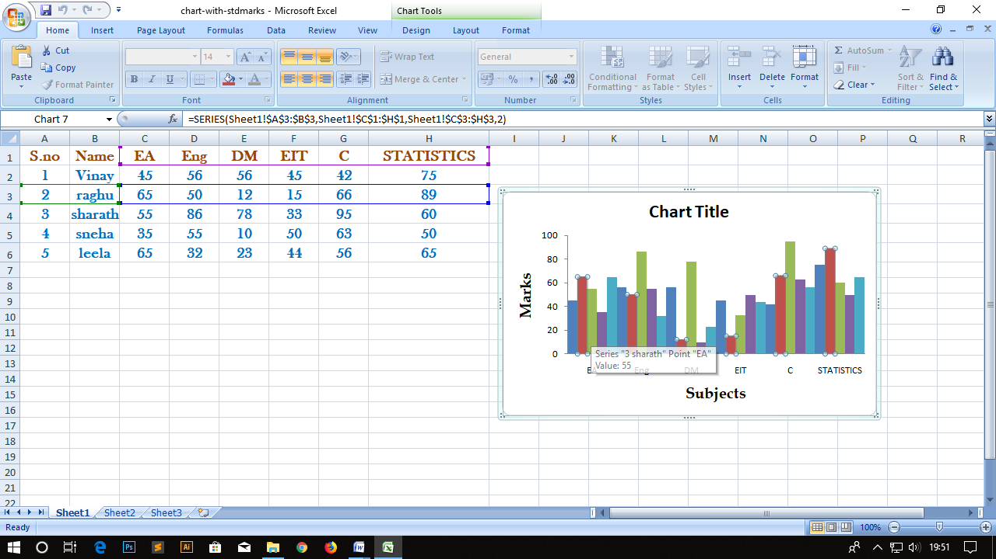

**4**, **Create a student table with Result and Grade**

**Procedure :**

* Click “START” button on desktop.
* Select “PROGRAMS” and click on “MS-OFFICE”. Then choose MS-Excel.
* Now you will see a blank excel sheet on the screen.
* On the tab at the upper left side of your screen, hit the “File” tab. On the vertical toolbar to the left, hit the “New” tab.
* Now enter the fields like “Student No”, ”Name” “ Discrete Mathematics” “Probability and Statistics”, “C-Programming “ ,“EIT” “Economic Analysis”, “Total Marks” ,“Average”, Result” and ”Grade”.
* Then enter the values to the fields of Student no, Name, Subjects.
* Then calculate values for “Total Marks” ,“ Average”,” Result” and ”Grade” for first row only.
* Formula for these fields is Total Marks:H2=(C2+D2+E2+F2)

Average: I2= =(H2/ 4)

Result:I2 =IF(AND(C2>=35,D2>=35,E2>=35,F2>=35),"Pass" ,"Fail")

Grade:k2=IF(AND(H2>=65,I2>=”PASS”),"GRADE1",IF(AND(H2>=50,",I2>=”PASS”),"GRADE2",IF(AND(H2>=35",I2>=”PASS”),"GRADE3", ‘Fail"))).

* Then drag the fields down to calculate the values to all rows.
* It will gives the values of all rows.
* Once you finished with your worksheet by entering the details of student marks and their total marks and percentage of marks, go to “File >Save As” and save your file so that you can retrieve it later.

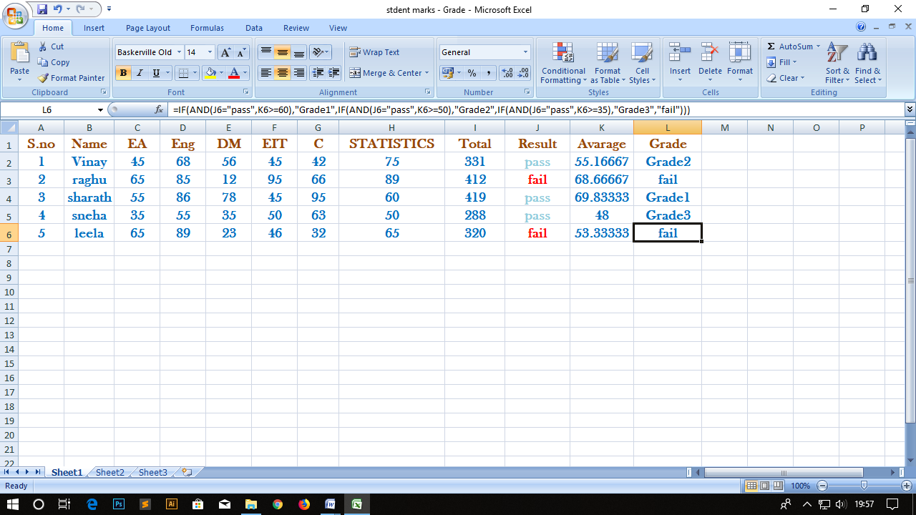

**5,** **Prepare Employee salary**

**Procedure:**

* Click “START” button on the desktop.
* Select “Programs” and click on MS-OFFICE. Then choose Ms-excel.
* Now we will see a blank excel sheet on the screen.
* On tab at the upper left side of your screen, hit the “File” tab. On the vertical tool bar to the left, hit the “New” tab.
* Now enter the Sample data of “Employee Salary”.
* Select the entire data and excel sheet. And, insert the basic salary, and use the formula to find the OA, HRA, GROSS, IT and NET PAY.
* HRA: =C2*10/100.
* 0A: =C2*15/100.
* GROSS PAY=Basic salary + OA+ HRA =C2+D2+E2.
* NET PAY=GROSS PAY-IT=F2-G2.

Save the presentation by clicking “Save” option in menu

* Once you finished with your worksheet by entering the details of student marks and their total marks and percentage of marks, go to “File >Save As” and save your file so that you can retrieve it later.

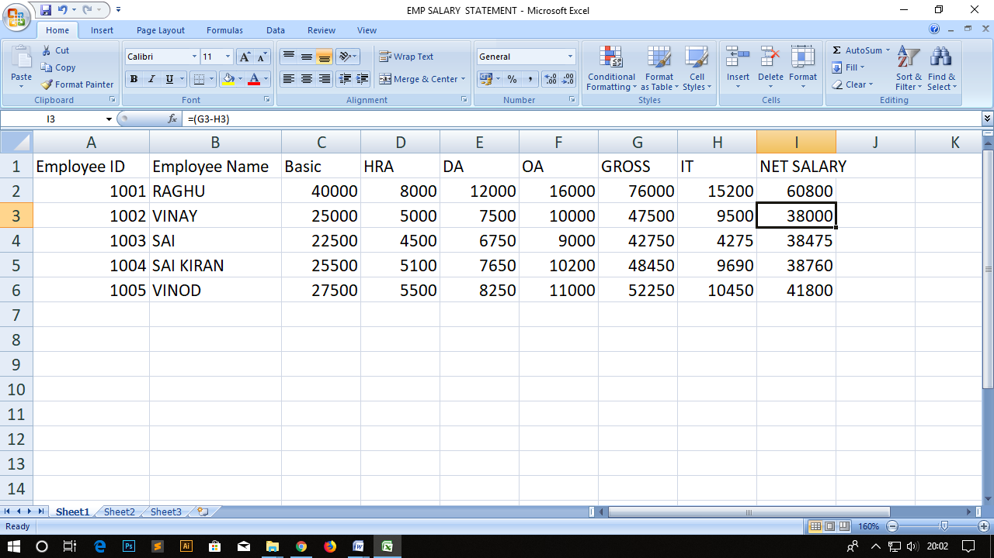

**6,** **Create product bill for 5 items by giving discount**

**Procedure**

* Click “START” button on desktop.
* Select “PROGRAMS” and click on “MS-OFFICE”. Then choose MS-Excel.
* Now you will see a blank excel sheet on the screen.
* On the tab at the upper left side of your screen, hit the “File” tab. On the vertical toolbar to the left, hit the “New” tab.
* Now enter the given fields. And, give the data what you want.
* Now calculate the data and calculate the total price of the product.
* Total bill: =E2+E3+E4+E5
* Discount: =IF(E7>=4000,20*E7/100,IF(E7>=3000,15*E7/100,IF(E7>=2000,10*E7/100,IF(E7>=1000,5*E7/100,0)))).
* Once you finished with your worksheet by entering the details of student marks and their total marks and percentage of marks, go to “File >Save As” and save your file so that you can retrieve it later.

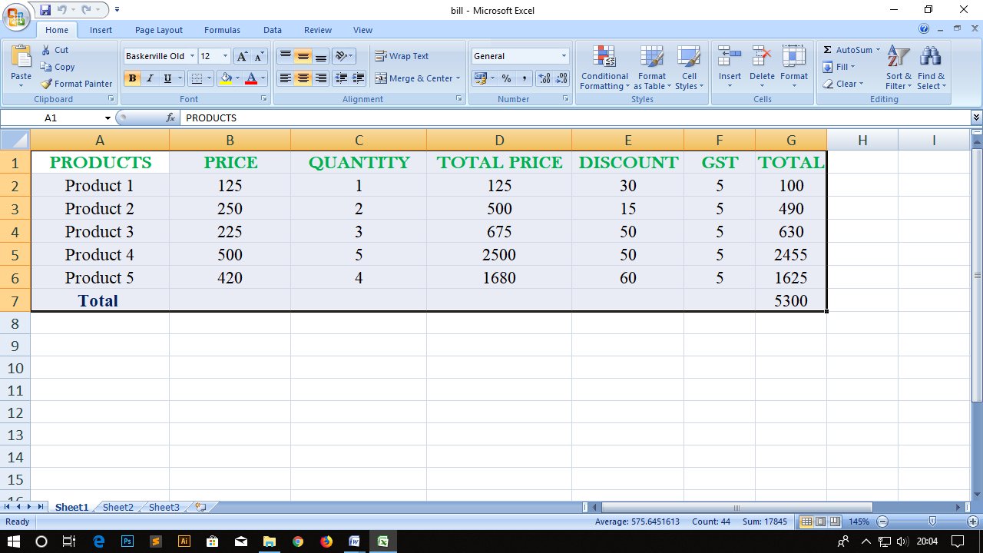

**7,** **Create student table and sort the data according to their percentage of marks**

**Procedure:**

* Click “START” button on desktop.
* Select “PROGRAMS” and click on “MS-OFFICE”. Then choose MS-Excel.
* Now you will see a blank excel sheet on the screen.
* On the tab at the upper left side of your screen, hit the “File” tab. On the vertical toolbar to the left, hit the “New” tab.
* Now enter the fields like “Student No”, ”Name” “ Discrete Mathematics” “Probability and Statistics”, “C-Programming “ ,“EIT” “Economic Analysis”, “Total Marks” ,“Average”, percentage” .
* Then enter the values to the fields of Student no, Name, Subjects.
* Then calculate values for “Total Marks” ,“ Average”,” percentage” for first row only.
* Formula for these fields is Total Marks:G2=(C2+D2+E2+F2)

Average:H2=(H2/ 4)

Percentage:I2=(G2//500)*100.

Then drag the fields down to calculate the values to all rows.

* It will gives the values of all rows.
* Then sort the data according to their percentage.
* To sort the data select the data go to “HOME” in that click on “Sort and filter”
* Go to custom sort and sort by percentage.
* Once you finished with your worksheet by entering the details of student marks and their total marks and percentage of marks, go to “File >Save As” and save your file so that you can retrieve it later.

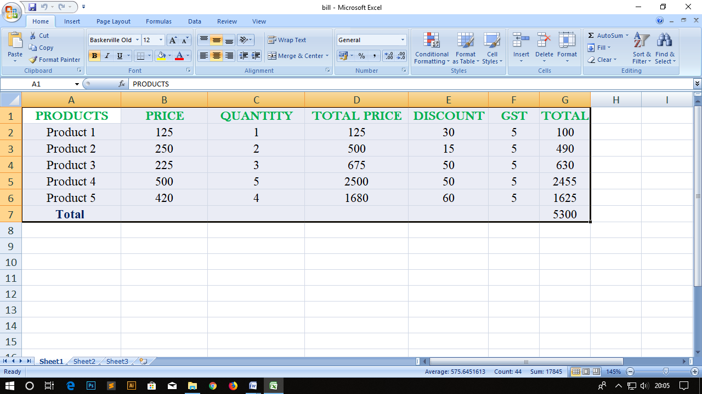

**8, Create a Macro in Excel**

**Procedure:**

* Click “START” button on desktop.
* Select “PROGRAMS” and click on “MS-EXCEL”. Then choose MS-Word.
* Now you will see a blank word document on the screen.
* Now “SAVE” the document by giving appropriating name. While you going to save the file you find a “SAVE AS” option in explorer bar i.e., the where you want to save the particular file.
* Select “Tool” option from menu bar and then select macro option.
* From that select “Record new macro”. Then give an appropriate name on showing window.
* After the recording of macro select option “Stop recording macro”.
* To use the macro go to macros in that view macros and run the macro
* Then use this macro where you want to use.

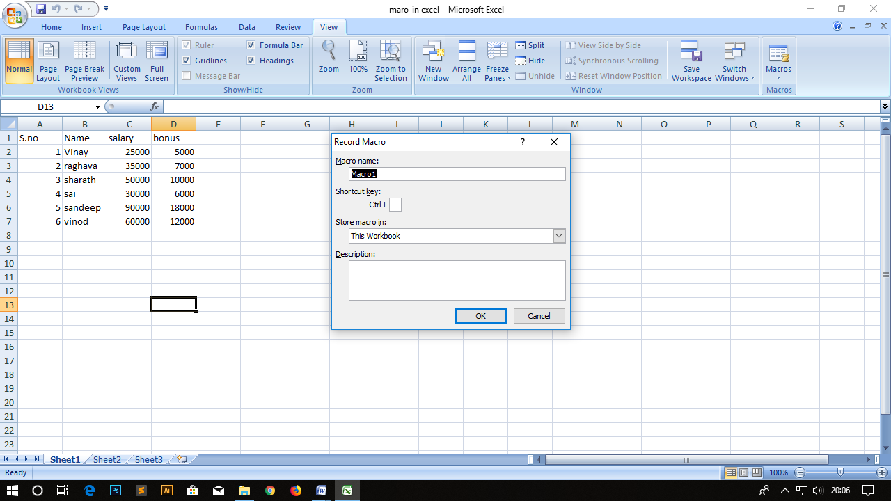

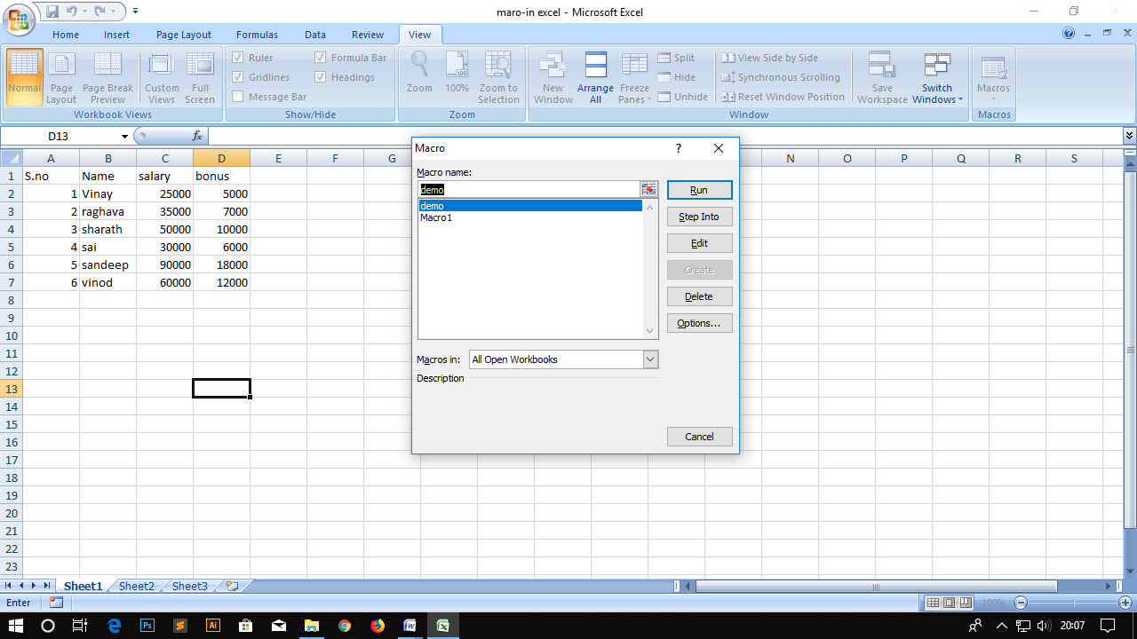

**MS-POWER POINT**

**1,** **Create a Power point Presentation About Myself With Minimum 5 Slides**

**Procedure:**

* Click “START” button on desktop and select “Programs”.
* Select “MS-OFFICE” & choose Microsoft power point.
* Go to “NEW” in that create a blank presentation to prepare slides.
* Now we have to select “New Slide” By choosing “New” option in main menu.
* In First Slide we add “Title”, click on right button to choose next slide.
* Then we write the presentation for myself. To required how many slides you want..
* Then click on slide show. The presentation will be started.

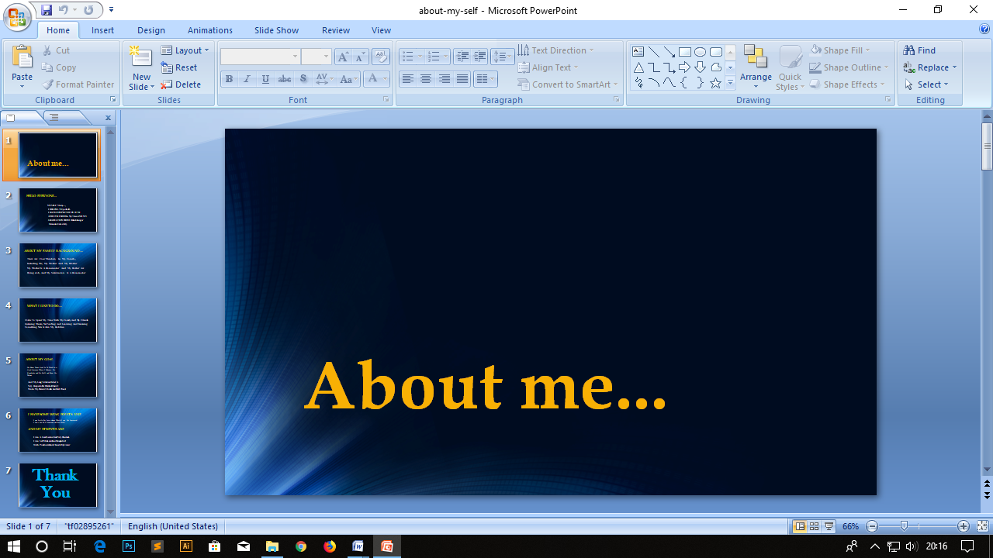

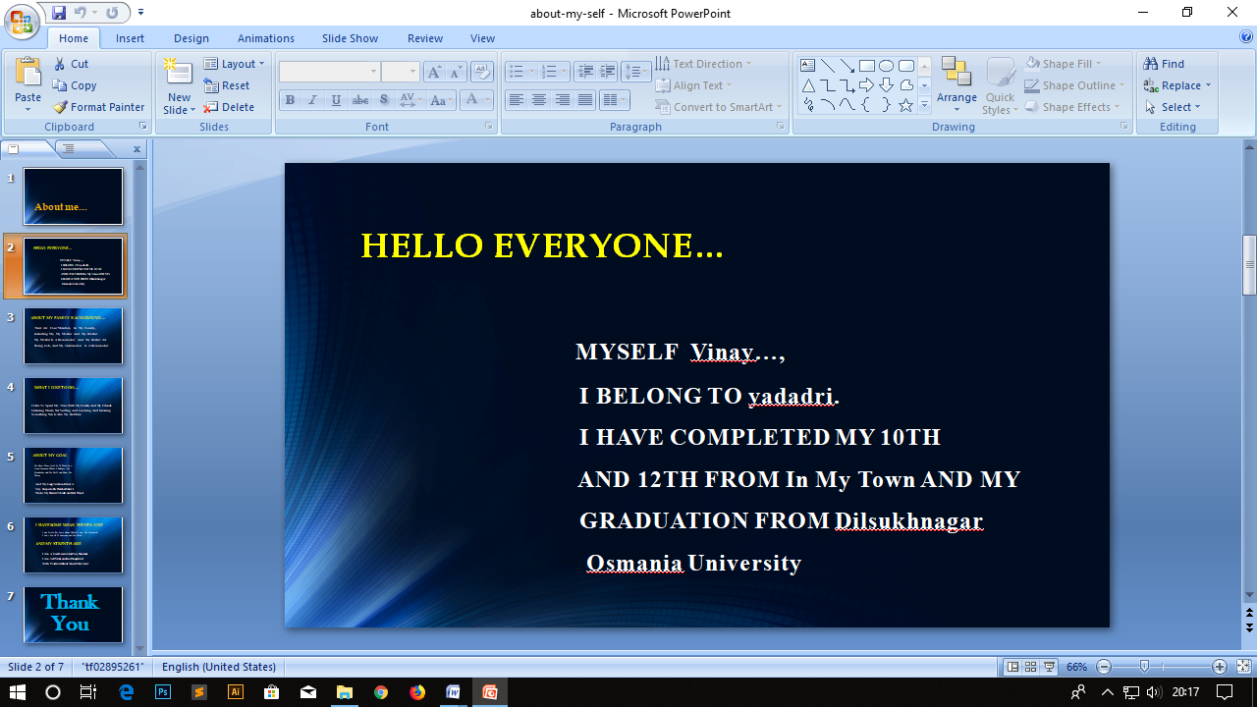

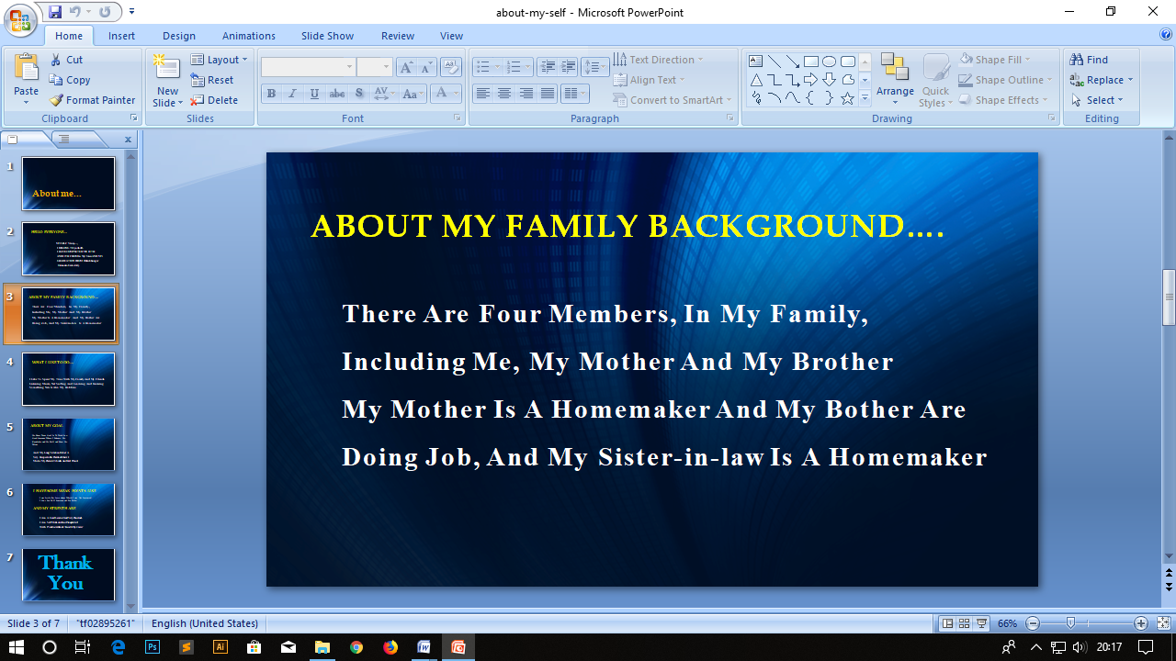

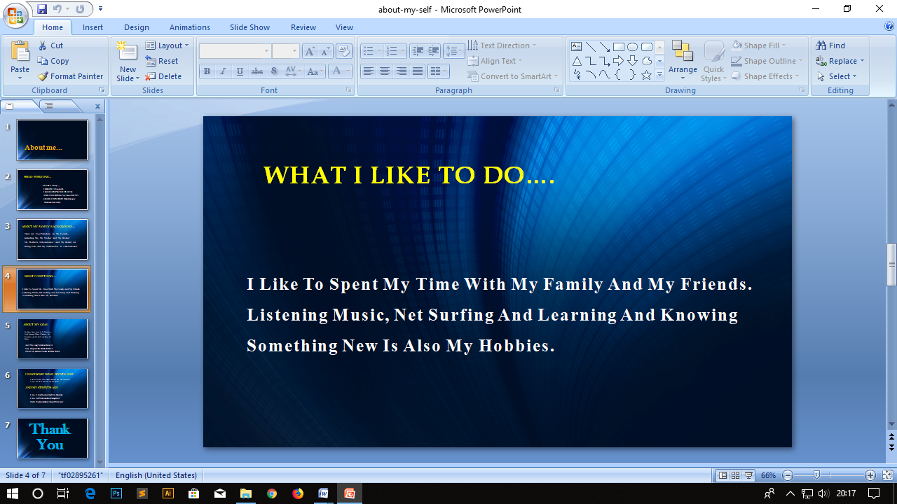

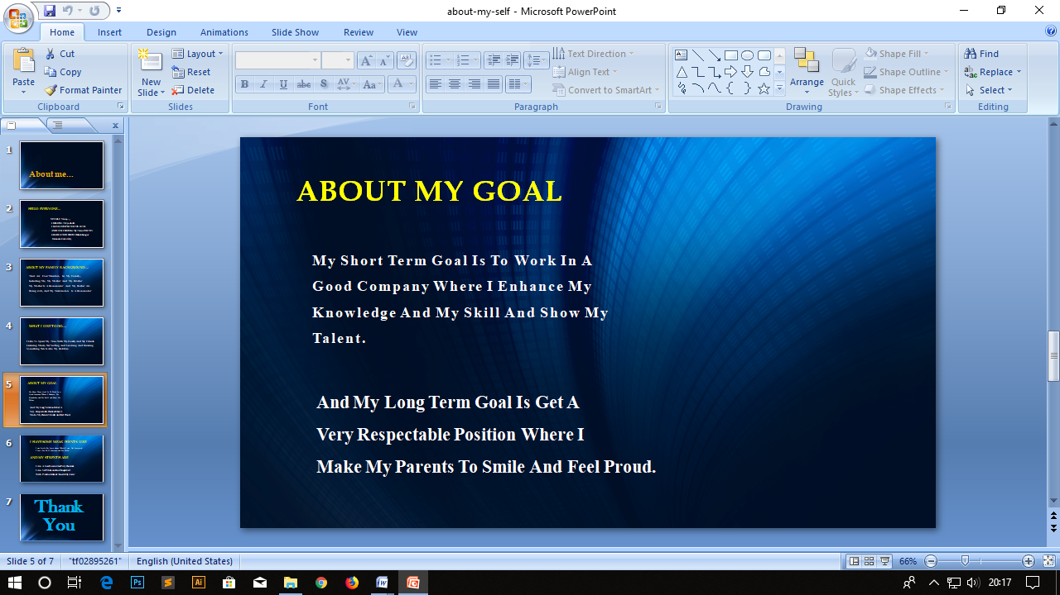

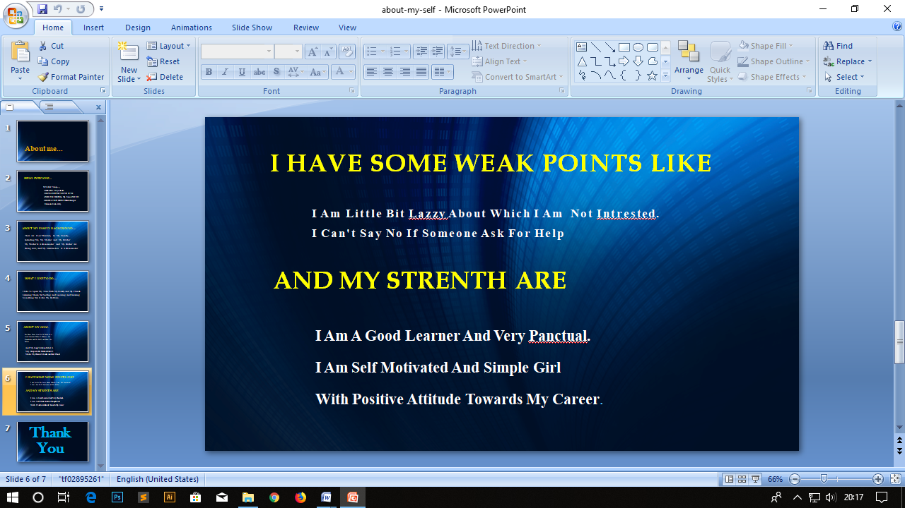



**2,** **Create a Power point Presentation About your City With Minimum 5 Slides**

**Procedure:**

* Click “START” button on desktop and select “Programs”.
* Select “MS-OFFICE” & choose Microsoft power point.
* Go to “NEW” in that create a blank presentation to prepare slides.
* Now we have to select “New Slide” By choosing “New” option in main menu.
* In First Slide we add “Title”, click on right button to choose next slide.
* Then we write the presentation for “HYDERABAD CITY”. To require how many slides you want.
* After the completion of our presentation go to “Animations”.
* By click on “Custom Animation”, and choose add effect, and modify the blinds.
* Click on automatic after, and set the ‘Time’ for each slide-> select for all.
* Then click on slide show. The presentation will be started.

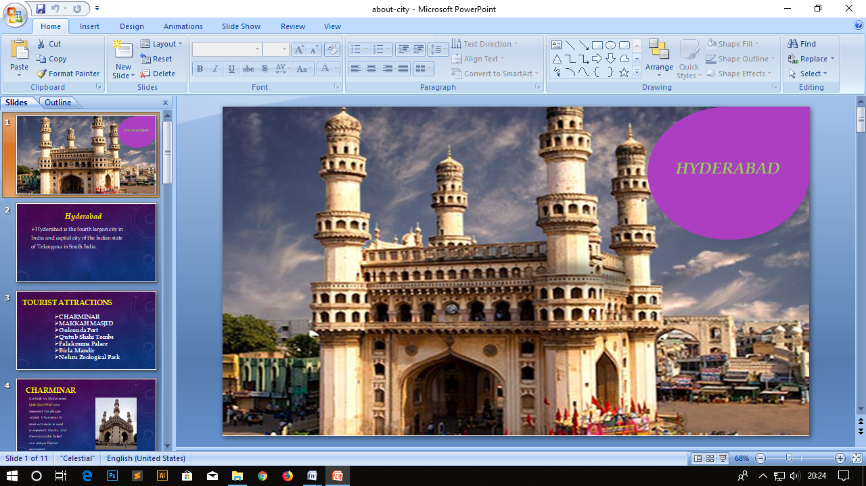

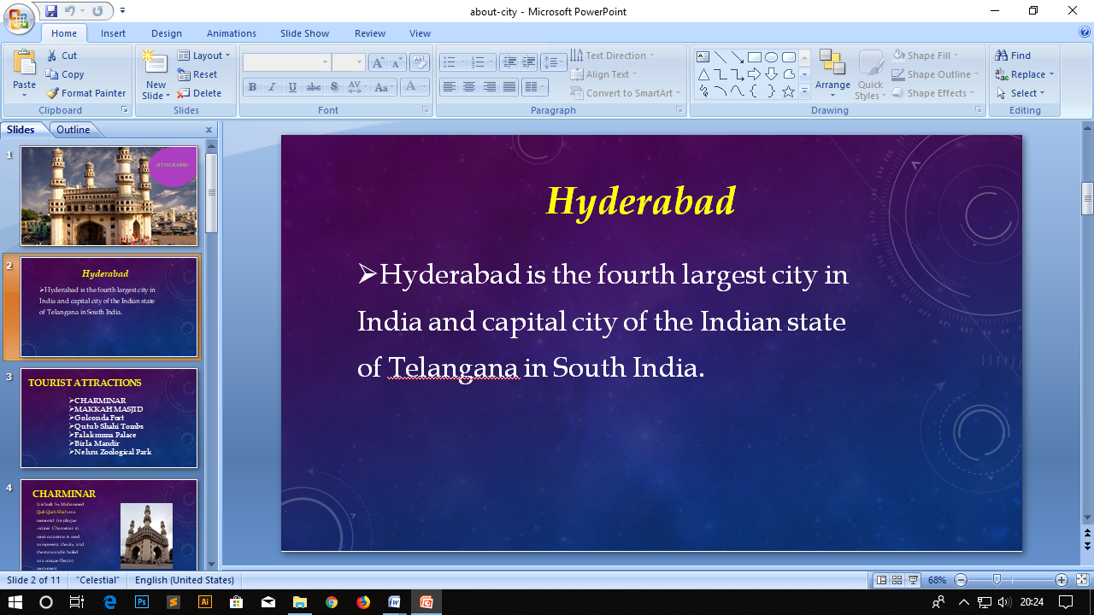

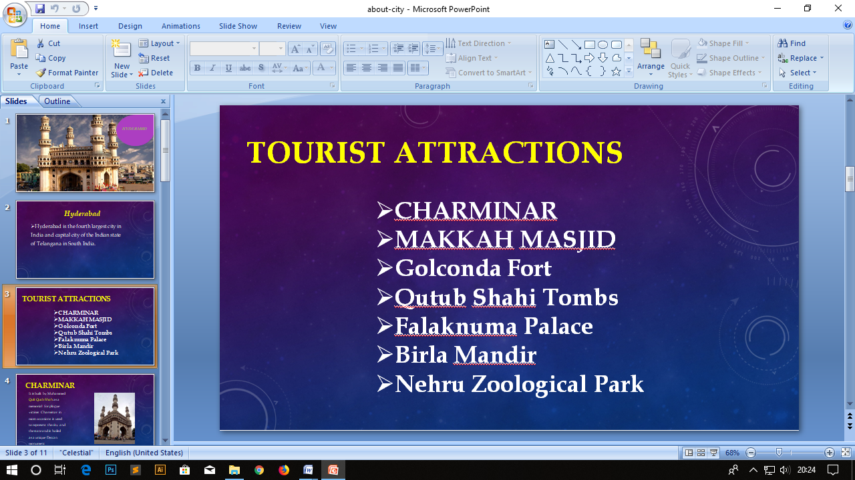 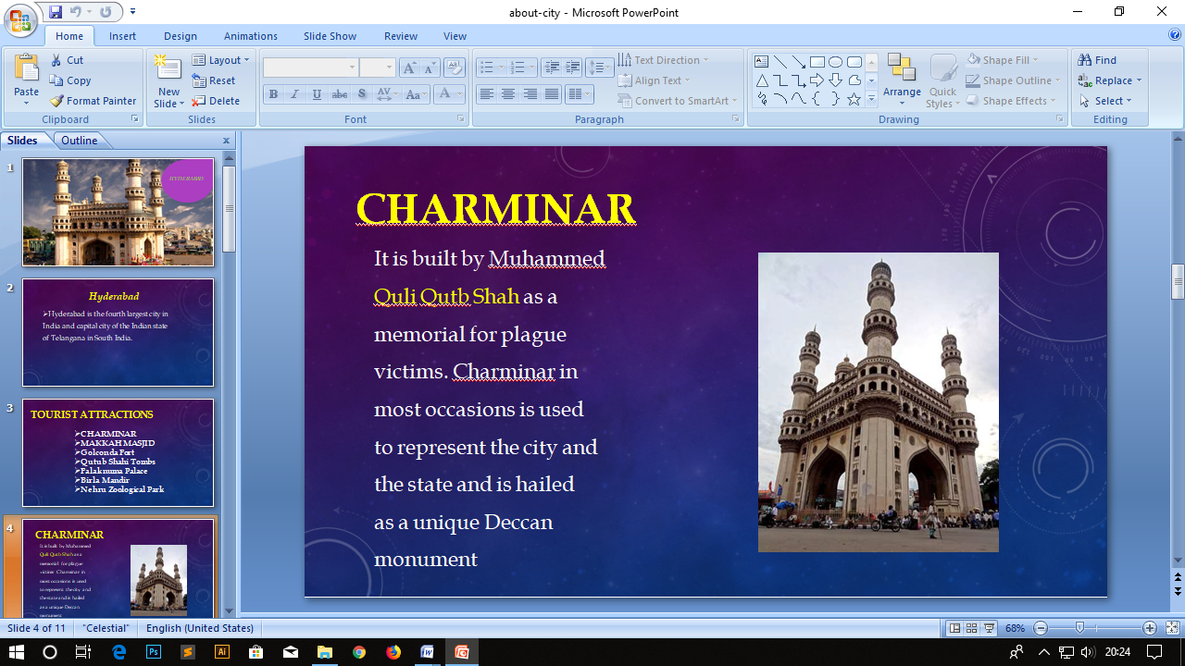

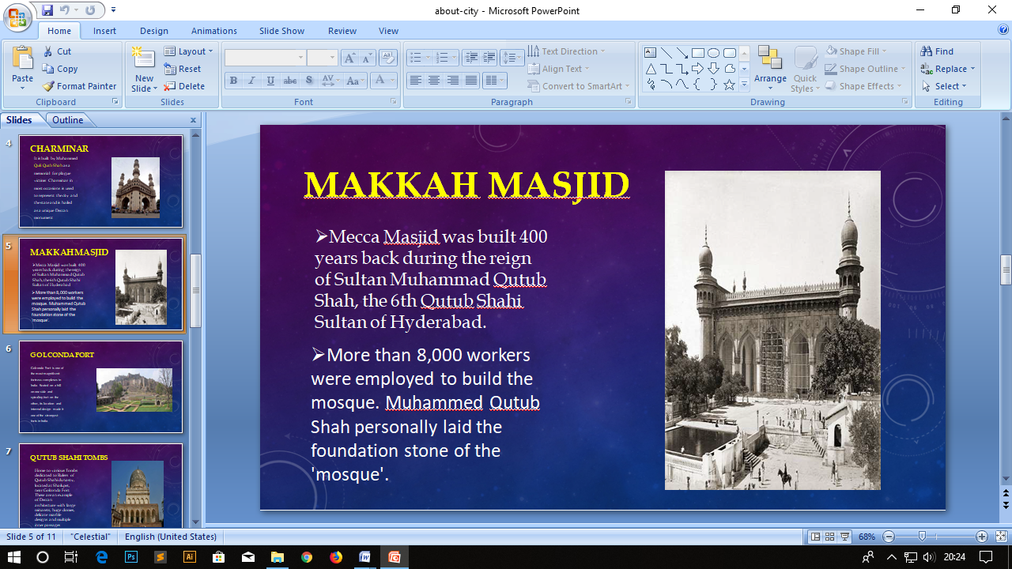

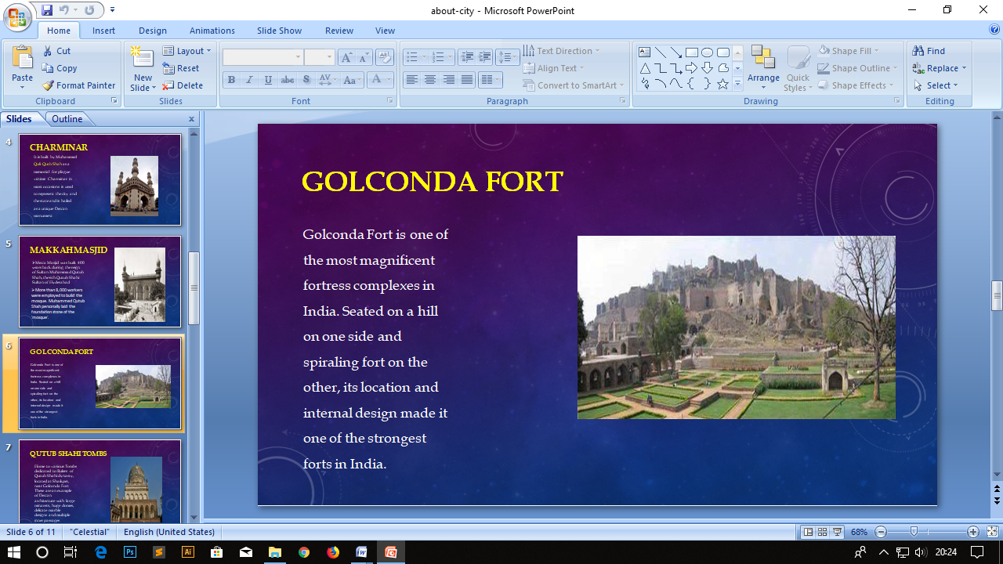

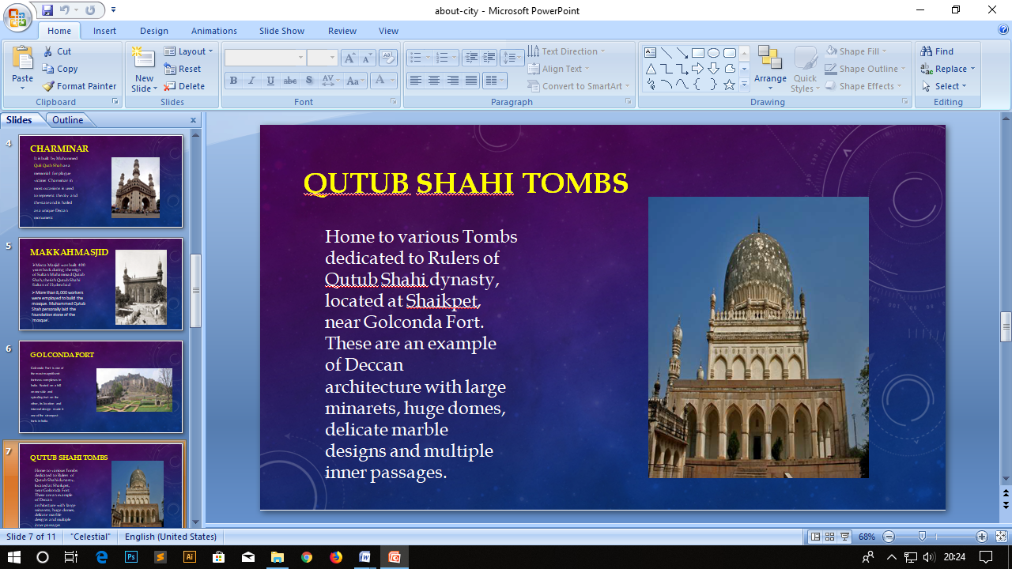

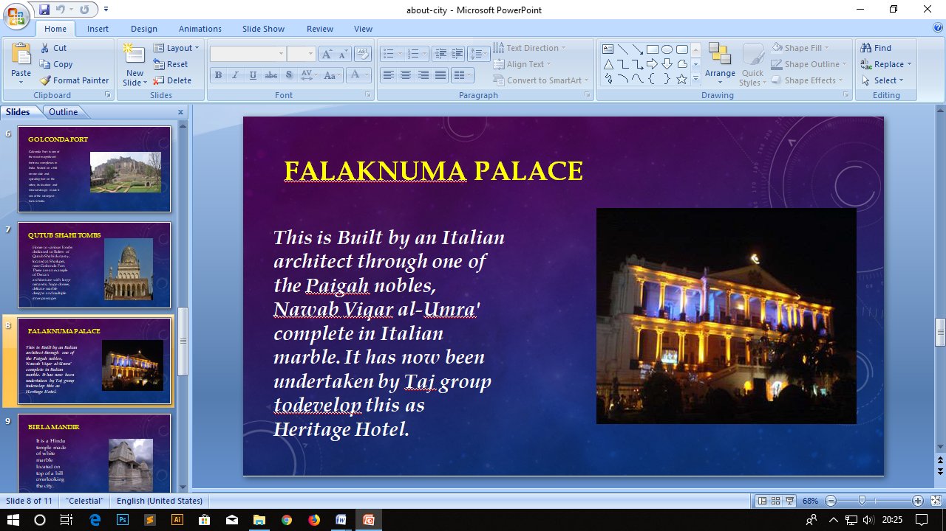

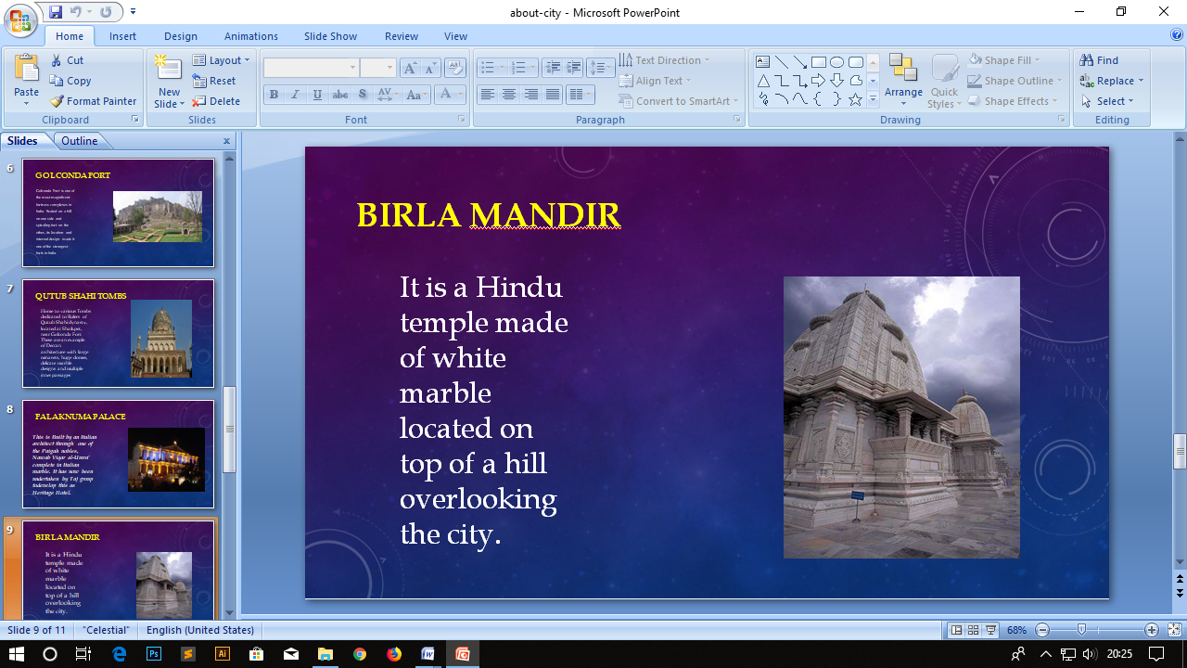

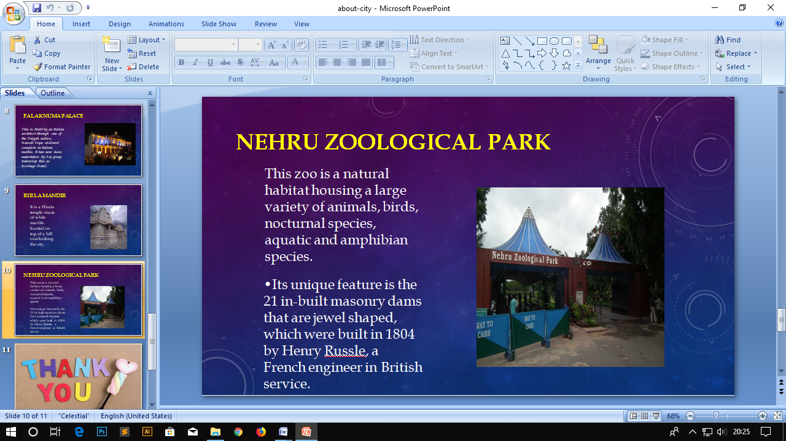



**3, Create a Power point presentation about Your Course With Minimum 5 Slide with animations.**

**Procedure:**

* Click “START” button on desktop and select “Programs”.
* Select “MS-OFFICE” & choose Microsoft power point.
* Go to “NEW” in that create a blank presentation to prepare slides.
* Now we have to select “New Slide” By choosing “New” option in main menu.
* In First Slide we add “Title”, click on right button to choose next slide.
* Then we write the presentation for “Your Course”.To required how many slides you want.
* After the completion of our presentation go to “Animations”.
* By click on “Custom Animation”, and choose add effect, and modify the blinds.
* Then click on slide show the presentation will be started.

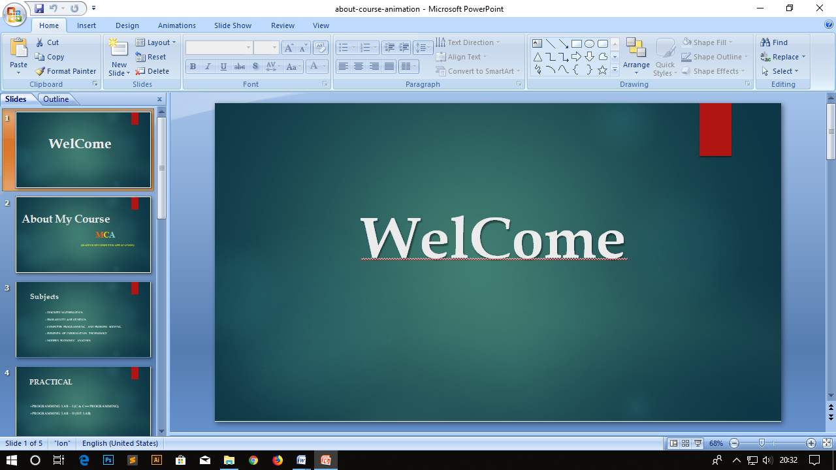

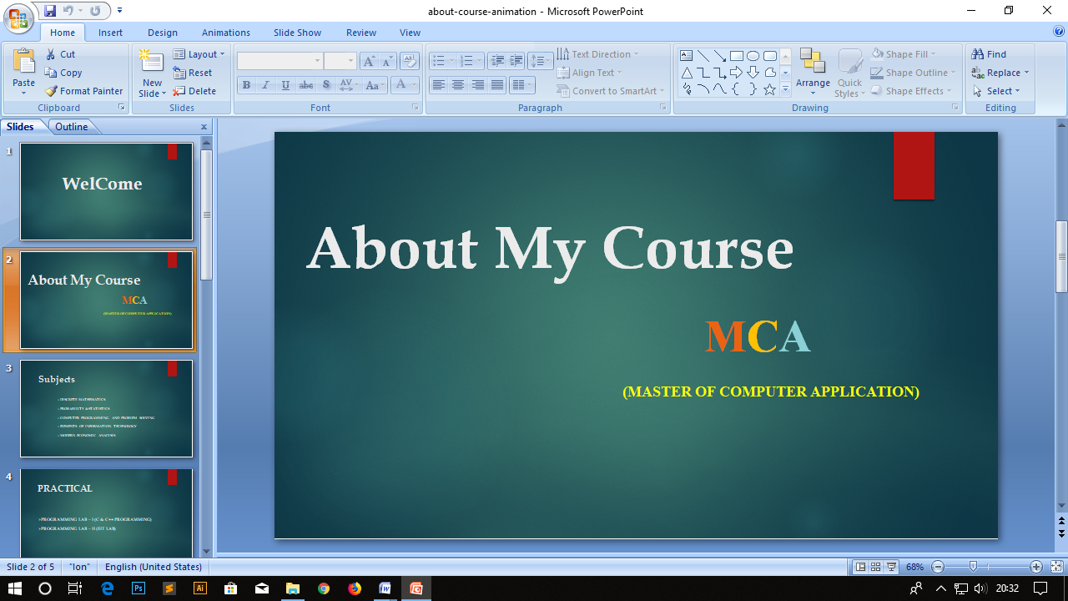

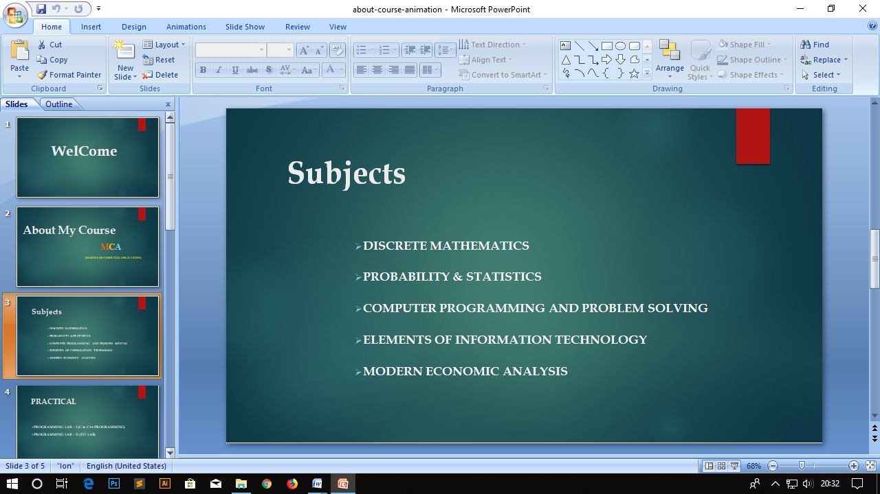

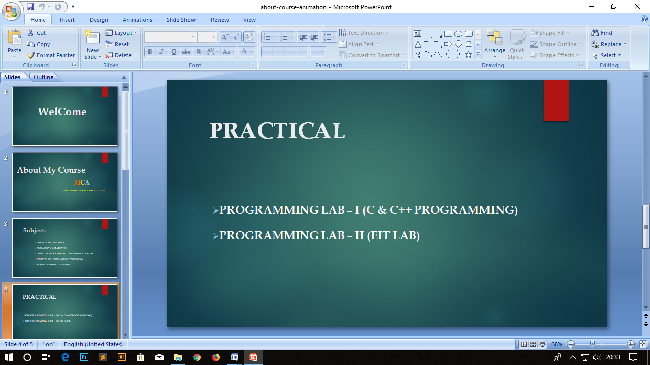

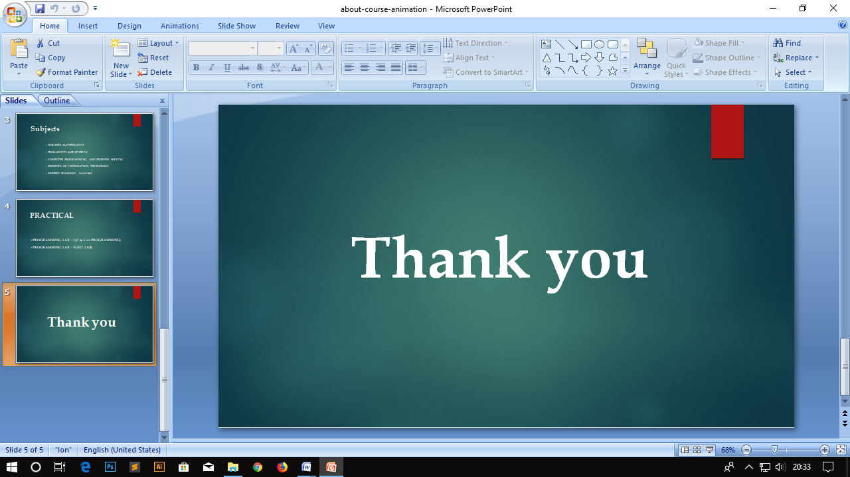

**MS-ACCESS**

**1, Create a student database and create student table using MS-Access. Create a form and report with minimum 10 records**

**Procedure:**

* Click “START” button on desktop.
* Select “PROGRAMS” and click on “MS-OFFICE”. Then choose MS-Access.
* Now you will see a Blank database on the screen.
* On the tab at the upper left side of your screen, hit the “File” tab. On the vertical toolbar to the left, hit the “New” tab.
* Enter data in the fields.
* Give “Primary Key” to the ID in the field section
* To create student database go to insert in that create table click on table design.
* Now select the “Design View” option in main menu bar.
* And, now enter the fields as much as you want. After that enter the data into the given fields

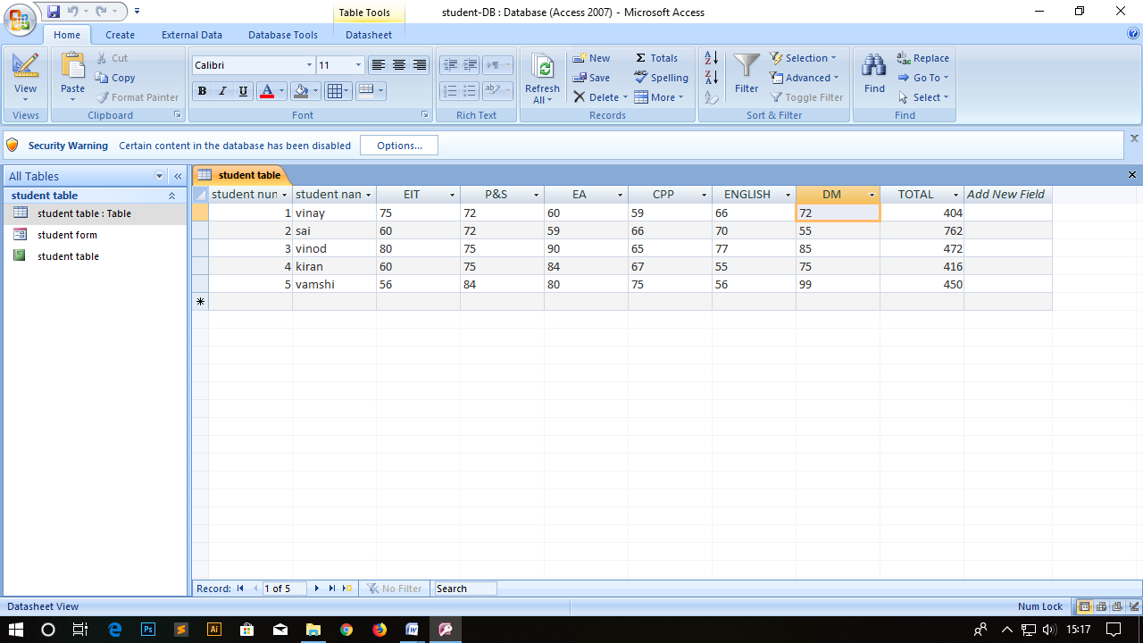

* Then create “Form” for the given data. For that select Form choose “Form Wizard” in the menu bar.
* To create a “Form” select the required fields in the student table.

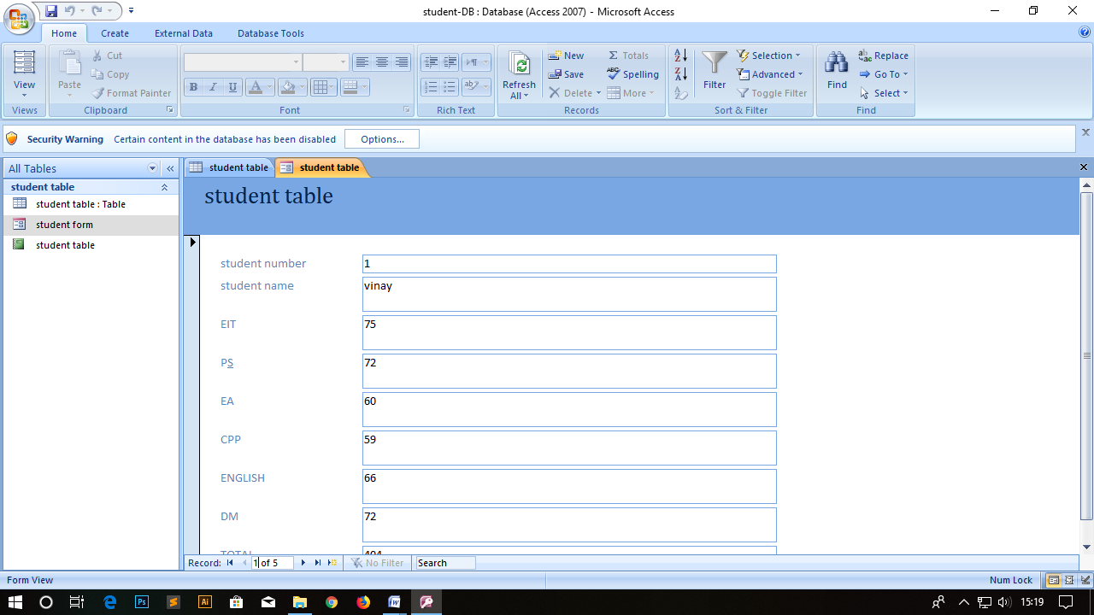

* Then create “Report” for the given data. For that select Report choose “Report Wizard” in the main menu bar.
* To create a “Report” select the required fields in the student table.

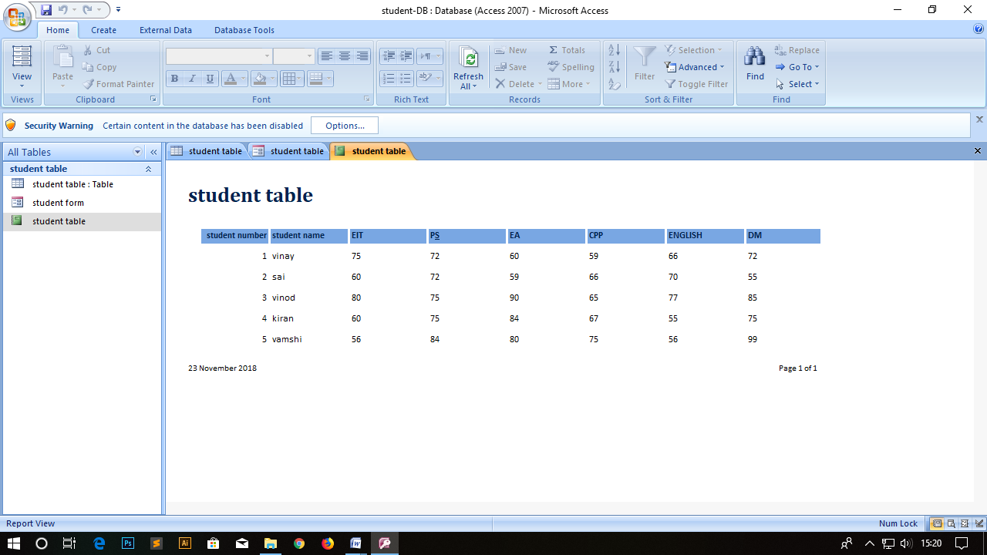

* Once you finished with your worksheet by entering the details of student marks and their total marks and percentage of marks, go to “File >Save As” and save your file so that you can retrieve it later.

**2, Create a Employee database using MS-Access.**

**Procedure:**

* Click “START” button on desktop.
* Select “PROGRAMS” and click on “MS-OFFICE”. Then choose MS-Access.
* Now you will see a Blank database on the screen.
* On the tab at the upper left side of your screen, hit the “File” tab. On the vertical toolbar to the left, hit the “New” tab.
* Enter data in the fields.
* Give “Primary Key” to the ID in the field section
* To create student database go to insert in that create table click on table design.
* Now select the “Design View” option in main menu bar.
* And, now enter the fields as much as you want. After that enter the data into the given fields.

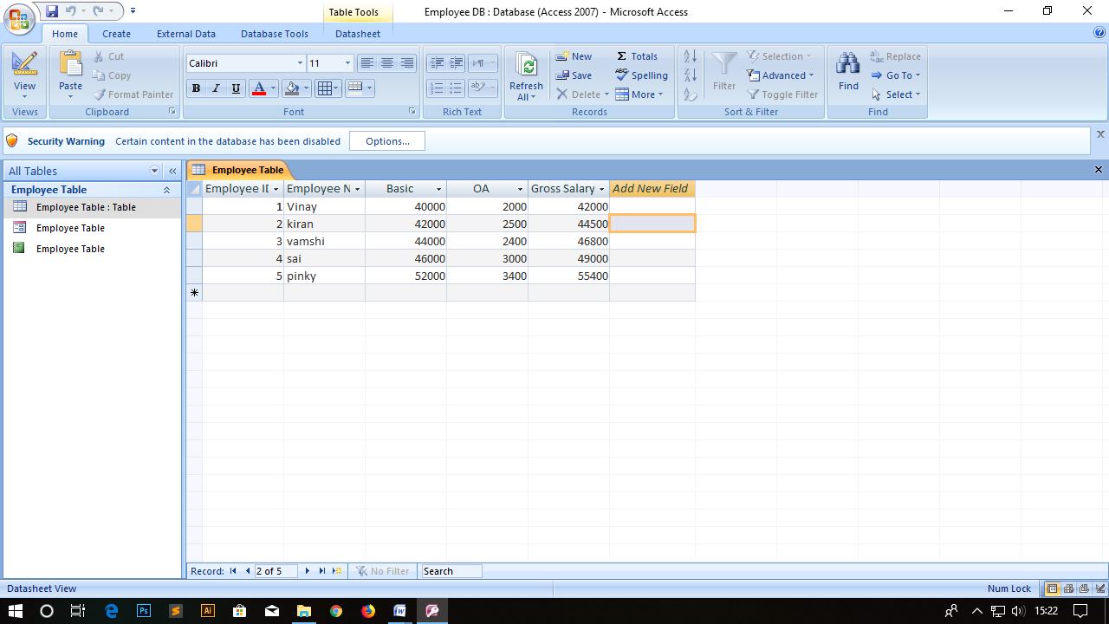

* Then create “Form” for the given data. For that select Form choose “Form Wizard” in the main menu bar.

To create a “Form” select the required fields form employee table

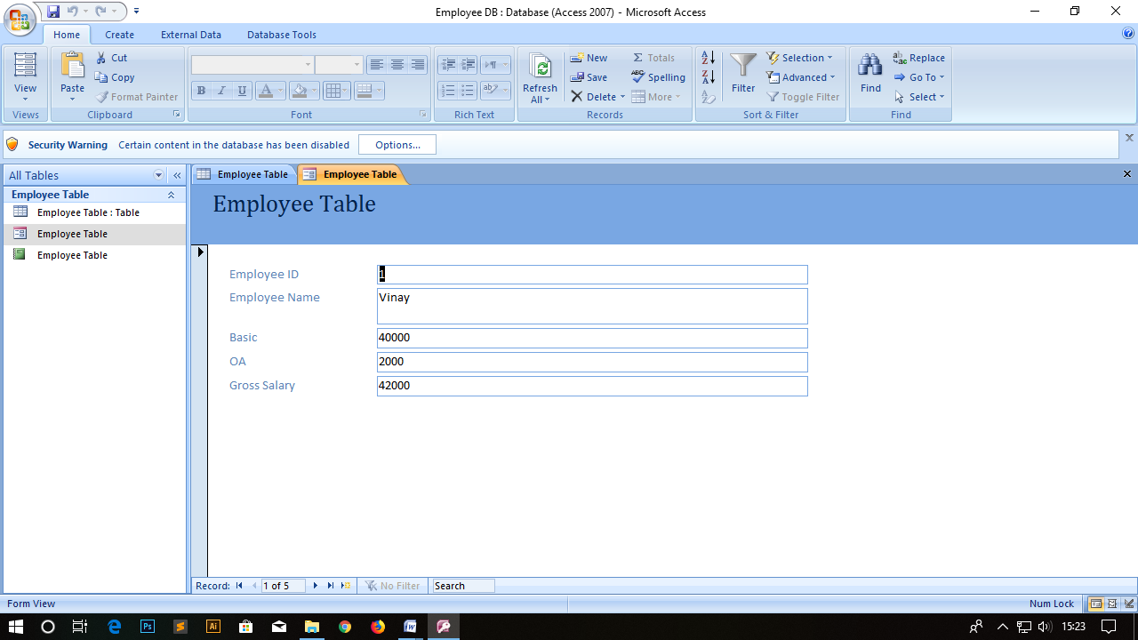

* Then create “Report” for the given data. For that select Report choose “Report Wizard” in the main menu bar.

To create a “Report” select the required fields from employee table .

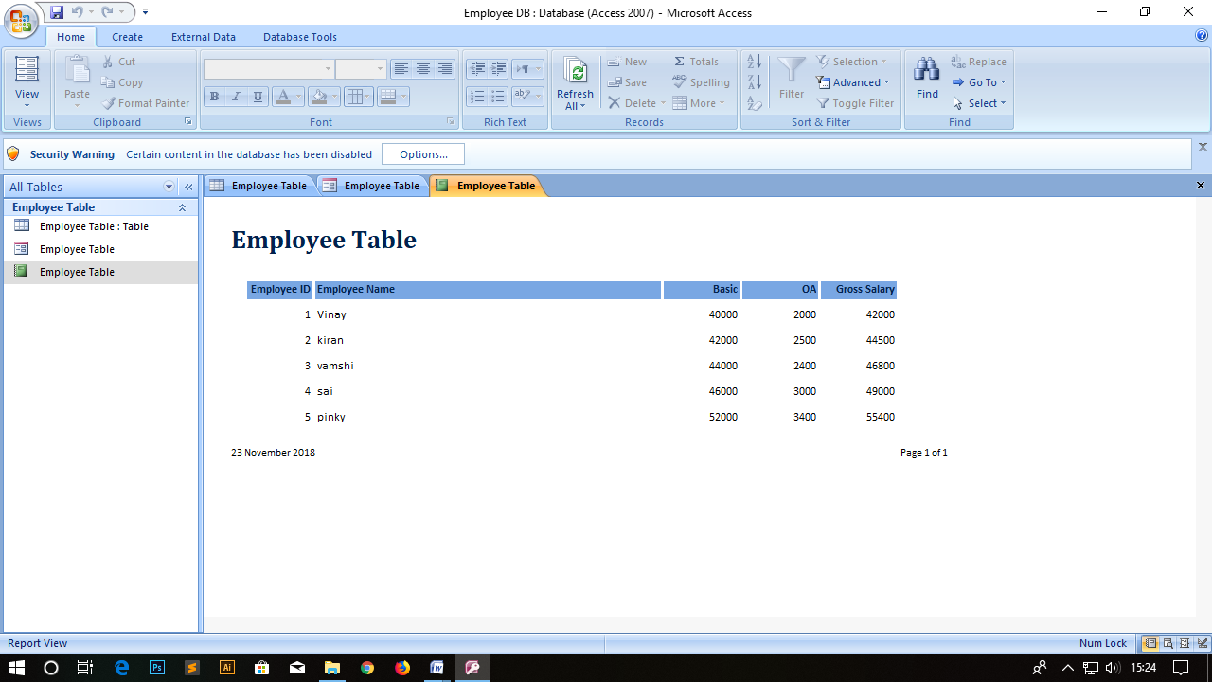

* Once you finished with your worksheet by entering the details of employee database, go to “File >Save As” and save your file so that you can retrieve it later.